**DCCD tree-ring archive**

**http://dendro.dans.knaw.nl**

**Manual**

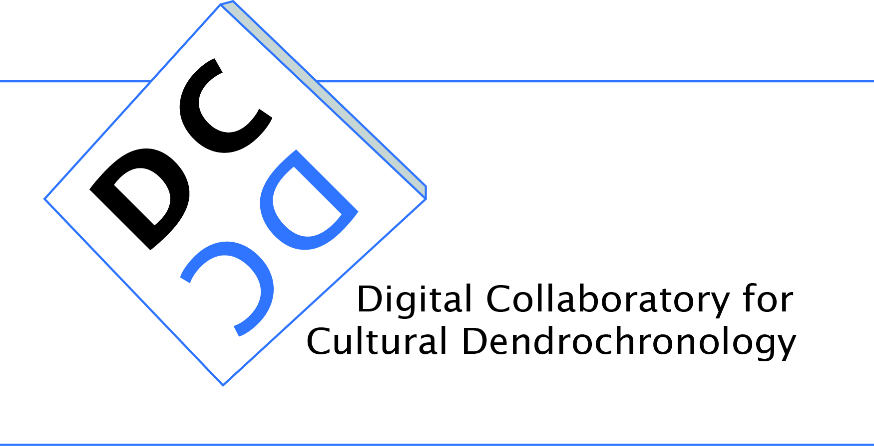

Esther Jansma

Rowin J. van Lanen  
Paul Boon

[e.jansma@cultureelerfgoed.nl](mailto:e.jansma@cultureelerfgoed.nl)

[r.van.lanen@cultureelerfgoed.nl](mailto:r.van.lanen@cultureelerfgoed.nl)

[paul.boon@dans.knaw.nl](mailto:paul.boon@dans.knaw.nl)

version 1.1

May 14th 2013, Cultural Heritage Agency of the Netherlands (RCE)

Data Archiving and Networked Services(DANS)

**Content**

**Introduction** 4

**DCCD visitors** 6

*DCCD homepage* 6

*“About” page* 7

*“FAQs” link* 8

*General query: how to do it* 8

*General query: what can be found?* 9

*Registering as a member* 10

**DCCD members** 11

Logging into the DCCD 11

*Username and password* 11

*Resetting a password* 11

Changing user settings 12

Uploading projects 13

*“Upload” page* 13

*Language setting* 14

*Verification of metadata file structure and content* 14

*Uploading single tree-ring value files* 14

*Uploading single associated files* 15

*Uploading multiple value/associated files* 15

*“Finalize” button* 15

*“Finalize and upload another” button* 15

*“Reset” button* 15

Draft projects 16

*“My Projects” environment* 16

*Editing draft projects* 16

*Editing draft projects: checking for errors* 18

*Leave edit mode* 18

Archiving projects 18

Unarchiving projects 19

Viewing projects 20

Data-access permission levels 20

*“Maximum security” access level* 20

*Project to Series permission levels* 20

*“Values”* permission level 21

Setting data-access permission levels 21

*Setting the default permission level* 21

*Setting alternative permission levels* 22

Changing data managers 24

Querying the DCCD repository 25

*General search* 25

*Advanced search* 27

*Spatially mapping query results* 29

*Spatially mapping query results* 30

*Downloading query results in XML* 31

*Opening an XML file containing DCCD query results* 32

Downloading DCCD projects 34

*Minimum download* 35

*Downloading original value files* 35

*Downloading additional value files* 35

*Downloading associated files* 35

*Remaining download options* 36

*Accepting the terms and conditions of DANS* 36

*Download command* 36

**Acknowledgements** 38

Project team of the DCCD infrastructure 38

Funding 38

**References** 40

**Introduction**

The dendrochronological data infrastructure DCCD consists of (a) tree-ring data standard TRiDaS; (b) software for interaction with the DCCD repository; (c) the DCCD repository; and (d) digital forums for communication, research, education and outreach. This manual describes how to use the DCCD repository.

The DCCD repository is an international and interactive digital library of tree-ring data situated at *Data Archiving and Networked Services* (DANS-KNAW) and accessible at <http://dendro.dans.knaw.nl>. Its content is developed through research of, among others, archaeological and palaeo-ecological sites, ship wrecks, buildings, mobile heritage (e.g. furniture, paintings) and living trees.

The DCCD repository uses the International Tree-Ring Data Standard TRiDaS for data storage (Jansma et al. 2010). It allows for conversion of other widely-used data formats using the dendrochronological data-conversion library TRiCYCLE (Brewer et al. 2011). It contains digital tree-ring measurement series and average ‘derived series’, as well as descriptive and interpretative metadata and associated files (e.g. research reports).

The user interface of the DCCD repository allows users to upload and download content, to edit metadata on line, to manage data access and to perform queries of the content. The DCCD repository conforms to EU best practices regarding the long-term preservation of digital research data.

The DCCD repository is a product of the research-infrastructure project Digital Collaboratory for Cultural Dendrochronology (DCCD) managed by Prof.dr. E. Jansma and was funded by the Netherlands Organization for Scientific Research (NWO, domain of The Humanities) and the Netherlands Cultural Heritage Agency (Rijksdienst voor het Cultureel Erfgoed). Utrecht University provided a Virtual Knowledge Centre (VKC) for DCCD-related communication and collaboration ([www.uu.nl/vkc/dendrochronology](http://www.uu.nl/vkc/dendrochronology)).

Please cite the following paper when referring to the DCCD: Jansma, E., R.J. van Lanen, P.W. Brewer & R. Kramer (in press): The DCCD: A digital data infrastructure for tree-ring research. Dendrochronologia (2012), <http://dx.doi.org/10.1016/j.dendro.2011.12.002>.

This manual has been written with great care, nonetheless errors and/or mistakes are inevitable. Any questions, ideas or additions to this manual or the DCCD in general are more than welcome and can be sent to [e.jansma@cultureelerfgoed.nl](mailto:e.jansma@cultureelerfgoed.nl).

**DCCD visitors**

The DCCD repository is an online digital library of tree-ring data and metadata, which lets its data contributors manage the access to their archived projects. Data contributors can alter default levels of data access and can adapt permissions for selected DCCD members at any time. Non-members can see and query public metadata, but cannot access deeper information levels.

*DCCD homepage*

The DCCD homepage at <http://dendro.dans.knaw.nl> is depicted below. It consists of several tabs and query possibilities, as well as links to background information and related websites. The default language of the DCCD is determined automatically using your computer settings, and can be changed using the “language” tab (top right). At present users can choose between Dutch, English, French or German. Note: most translations of the DCCD web pages are made automatically and therefore the texts may contain stylistic inaccuracies.

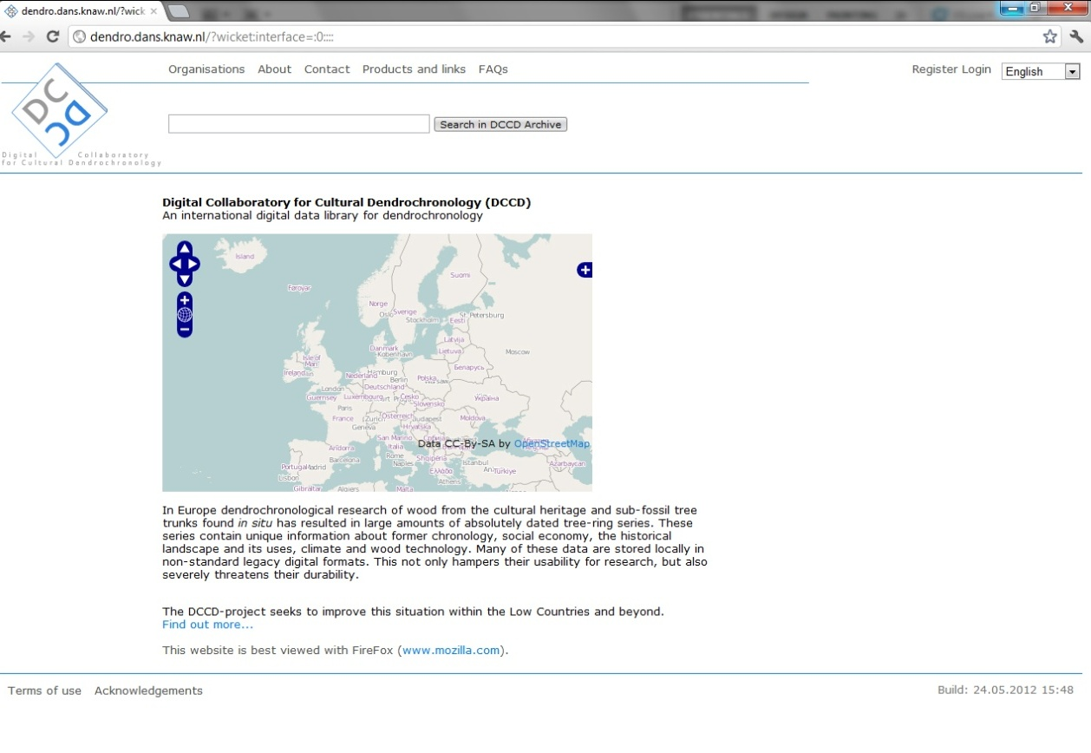

*“Organizations” tab*

The “Organisations” tab gives an overview of the different organisations connected to the DCCD repository. Clicking on an organization will provide contact information of this organisation (if this information has been entered into the DCCD).

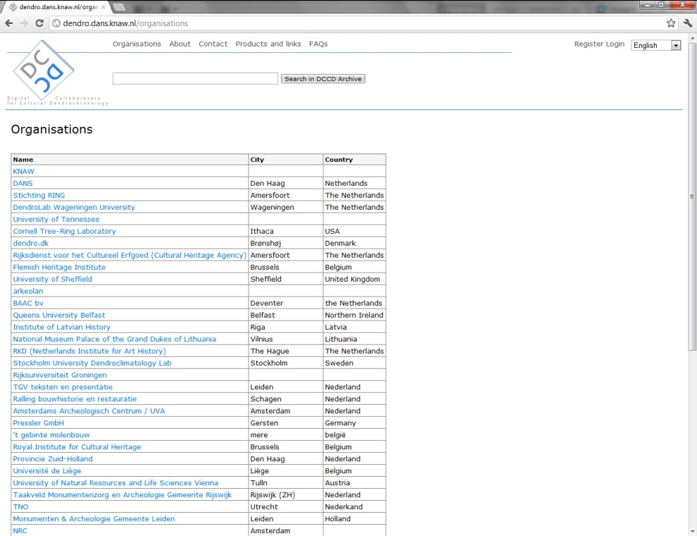

*“About” page*

The “About” page provides a link to background information about the DCCD repository.

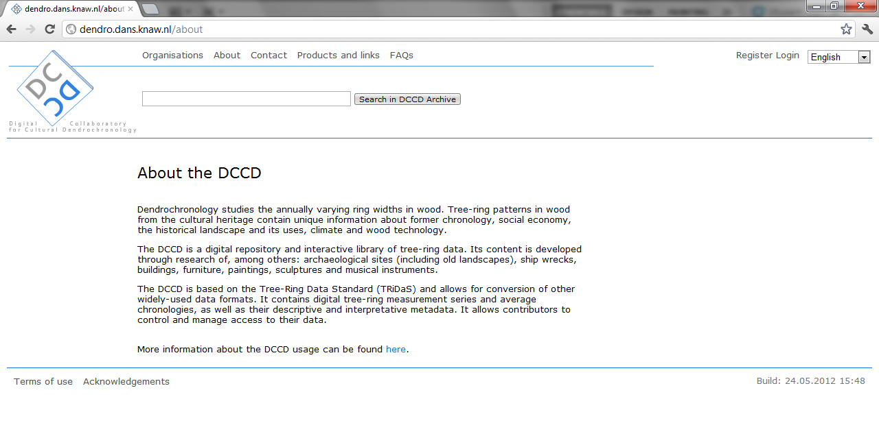

*“Contact” page*

The “Contact” page provides the contact details of the DCCD project manager. Feel free to contact the manager with any question you may have.

*“Products and links” page*

The “Product and links” page provides access to external products and tools of the DCCD infrastructure, such as its datamodel, software, and digital collaboration platform.

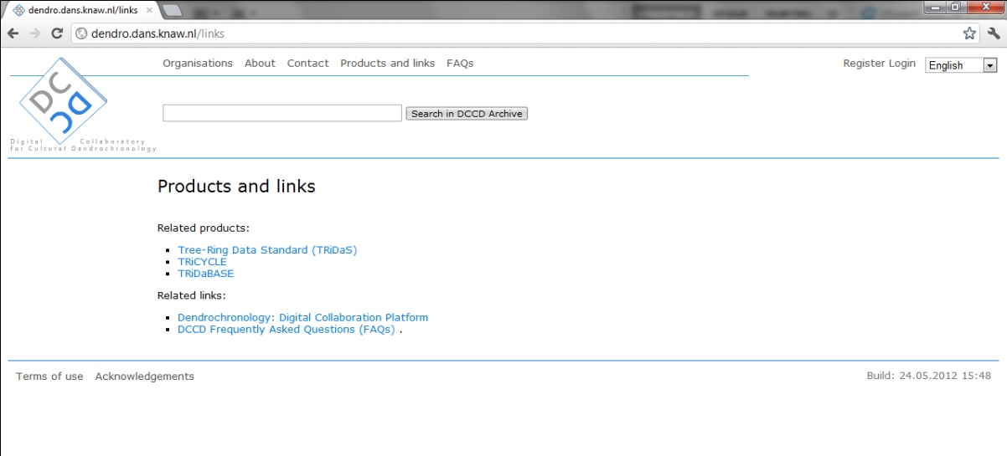

*“FAQs” link*

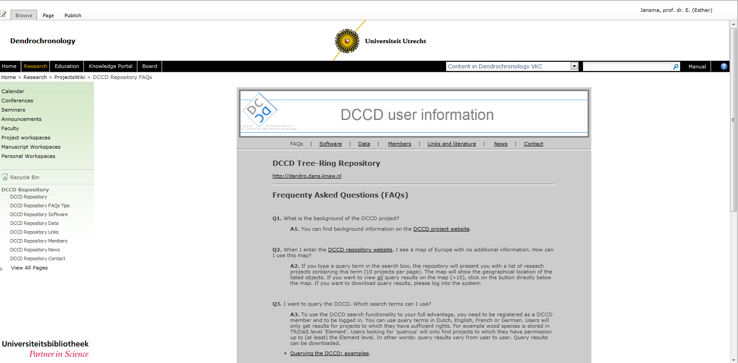The “FAQs” link to the right of the “Products and links” tab provides access to the Frequently Asked Questions section of the DCCD user-information website. The DCCD user-information website is maintained at the Virtual Knowledge Centre (VKC) for Dendrochronology at Utrecht University (<http://www.uu.nl/vkc/dendrochronology>), which serves as the DCCDs digital collaboration platform.

*General query: how to do it*

The “general search” field is located on the DCCD homepage and has the same basic functionality as commonly used search engines (e.g. Google, Yahoo). Visitors can perform a general query using the search bar and the “Search” button. A general query searches all fields that are indexed by the DCCD and that are unlocked by the permission levels of the projects. It results in a paginated project overview projects (10 projects per page) and a geographical overview of the listed projects. Clicking on a specific project or on the “refined search” button will result in the message that the user should log in.

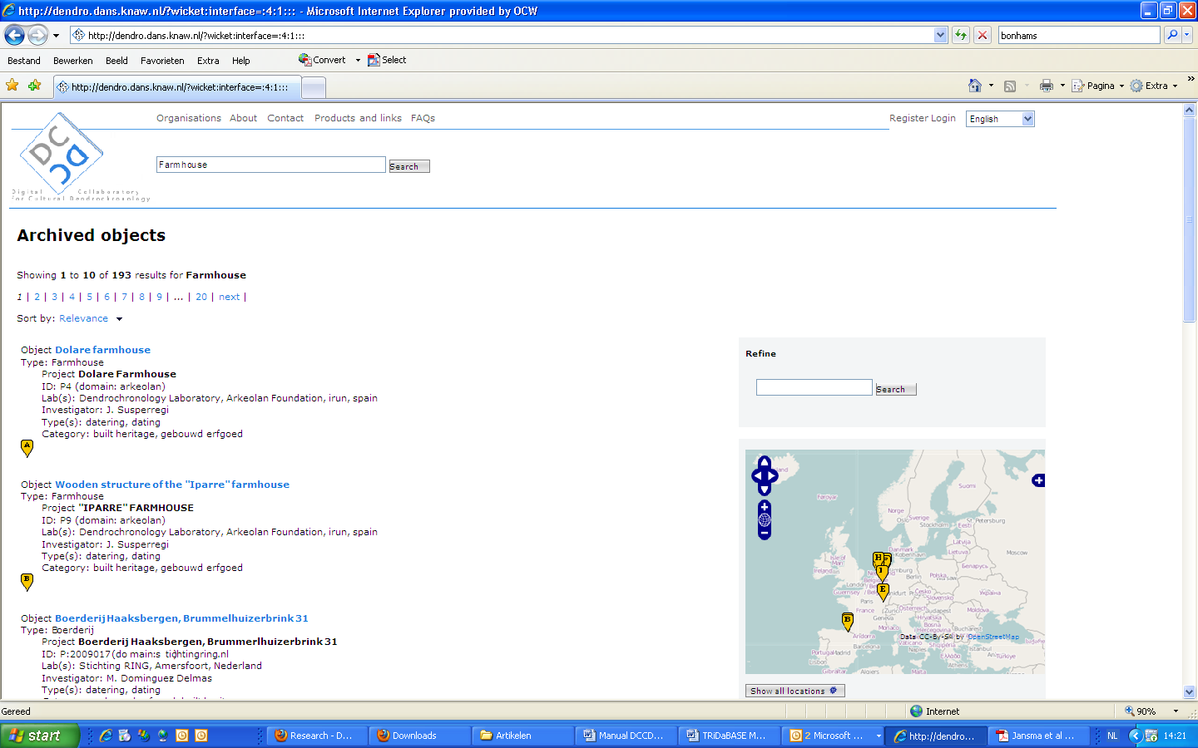

*General query: what can be found?*

A general query searches all fields that are indexed by the DCCD and that are unlocked by the permission levels of the projects. Entering a term such as “water well” in Dutch will also include English, French and German equivalents into the query-result list. The reason is that the DCCD repository uses a multilingual approach towards the following information: (a) **project category** (e.g., “archaeology”, “built heritage”; (b) **Object type** (e.g., “water well”, “farm house”); and (c) **Element type** (e.g., “pile”, “stave”). Currently the DCCD supports Dutch, English, French and German. The example below shows query results after searching for “stave”, with Dutch results to the left side of the screen and a result in English marked on the map to the right.

Note for DCCD data managers: location coordinates in TRiDaS are stored on the object and element level. Settings permission level of a project to the element level ensures complete spatial visibility of the objects and elements this project contains.

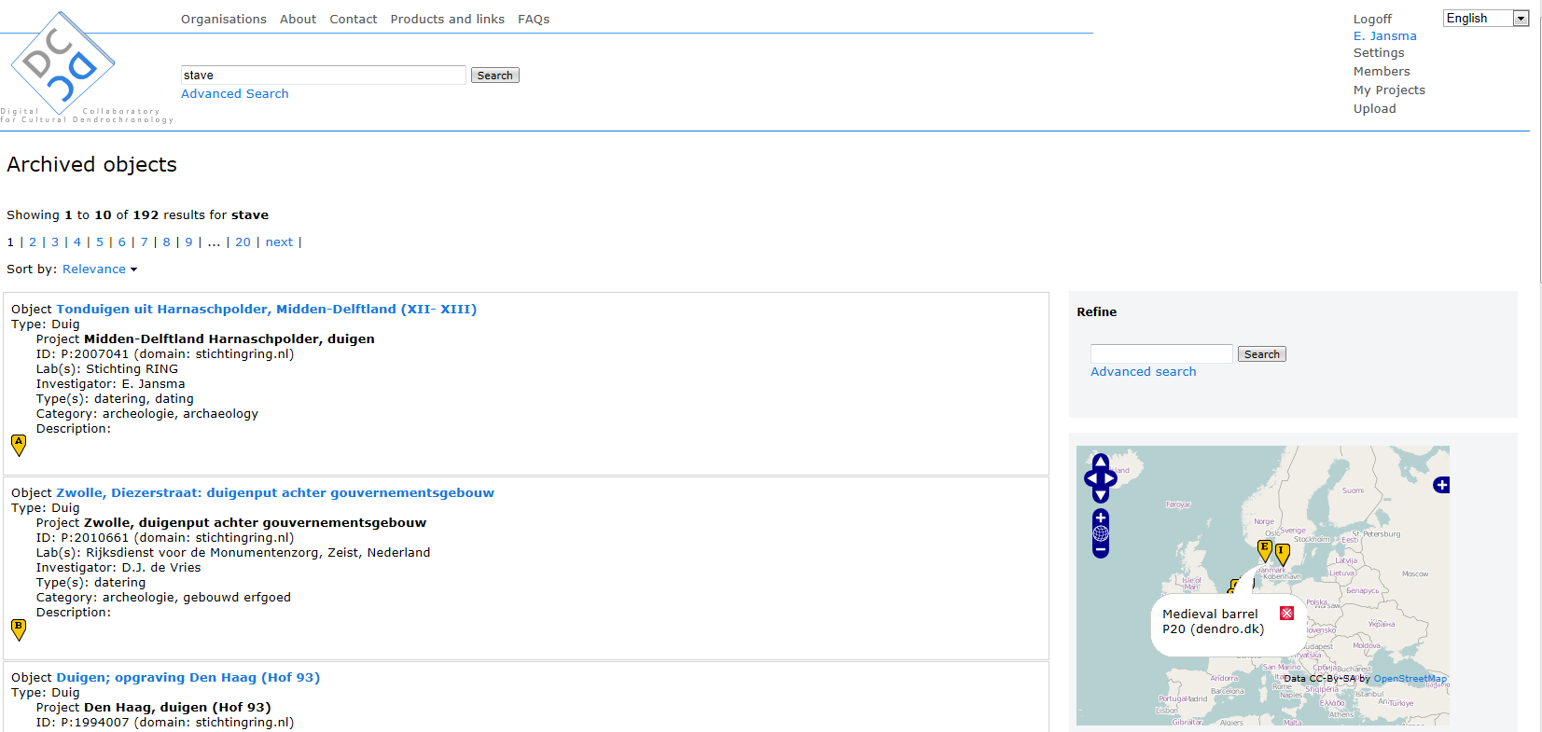

*Registering as a member*

Visitors can register as a DCCD member by clicking on the “register” button on the top right of the homepage. This opens up a registration form. Fields marked with an asterisk (*) are mandatory. An organization can be chosen from a list. It is also possible to add a new organization, by filling in its name, address, postal code, city and country. Your request will be sent to the DCCD manager who will verify your account and send you a link through which you can activate your account. This link is sent to the email address you have registered.

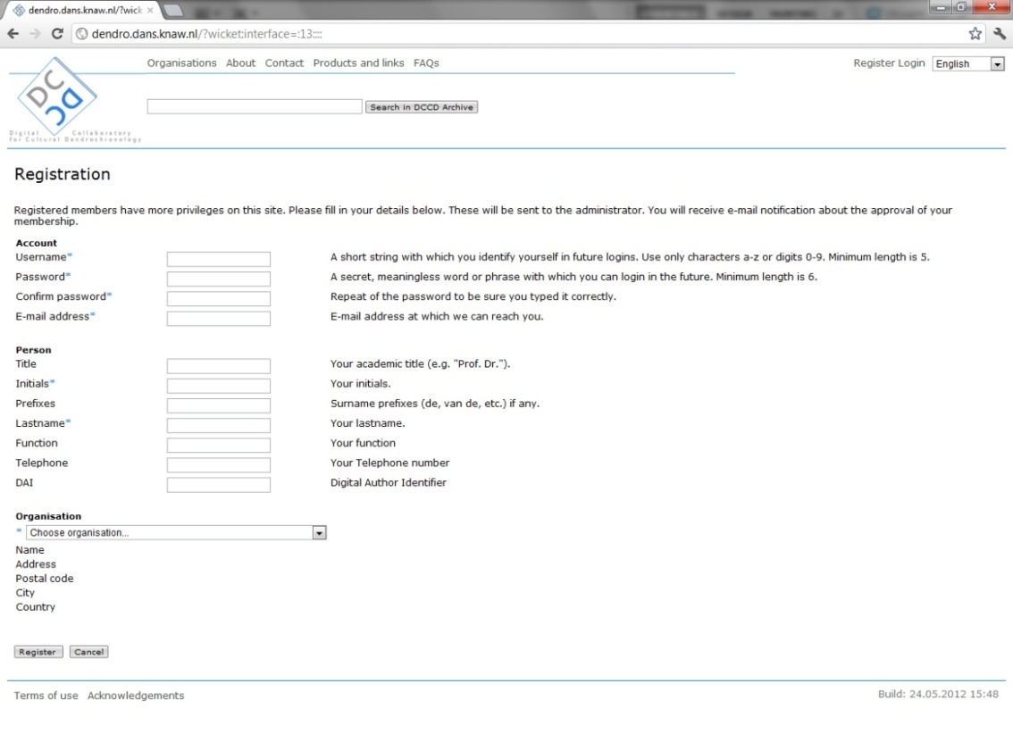

**DCCD members**

Logging into the DCCD

*Username and password*

Press the login button on the top right of the screen. The login screen of the DCCD asks for a username and password.

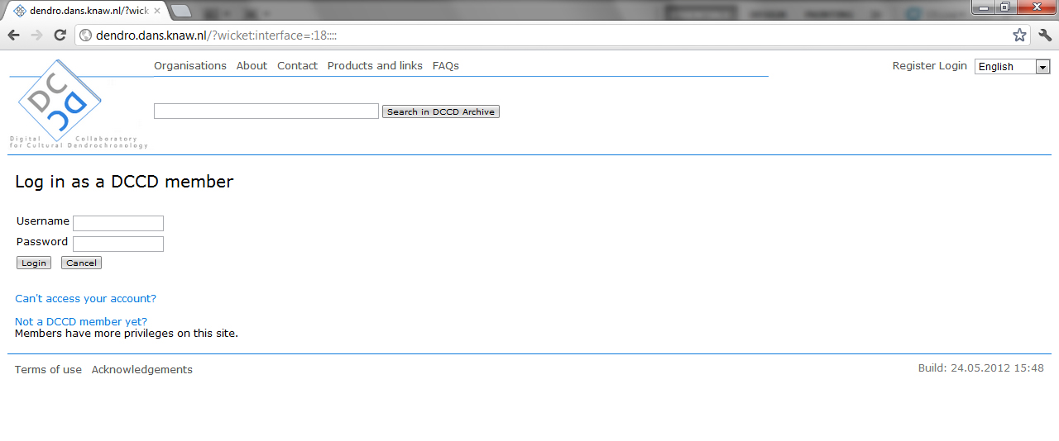

Fill in your username and password and click on the **login** button below the password field. After logging in you will see your username at the top right of the screen, as well as links to the pages that are connected to your account (‘Logoff’, ‘Settings’, ‘My projects’, ‘Upload’) and a “Members” page containing an overview of current DCCD members. Note: if your name is not displayed on the top right of the screen, you are not logged in and you should login before continuing.

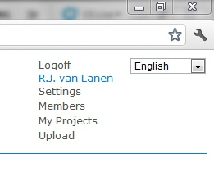

*Resetting a password*

Members who cannot access their account should click on the Login button and press on the “**Can’t access your account?**” button placed underneath the login fields. Here members can enter either their username or their email address. A temporary password will be sent to the registered email address. Members can use this new password to login the DCCD and change the temporary password using “**settings**” (see “Changing user settings”).

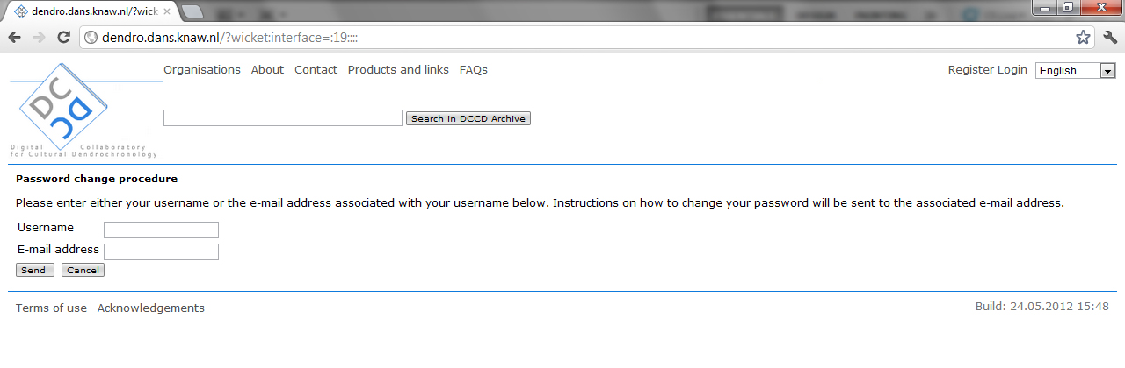

Changing user settings

Members can change their settings using the “**settings**” page. This page contains all information known to the DCCD about the user (e.g. username, display name, email address, function, telephone, organization). Here users can edit this information and/or change their password. To either edit user information or change the password click on the “Edit” and “Change password ”buttons on the bottom left of the screen.

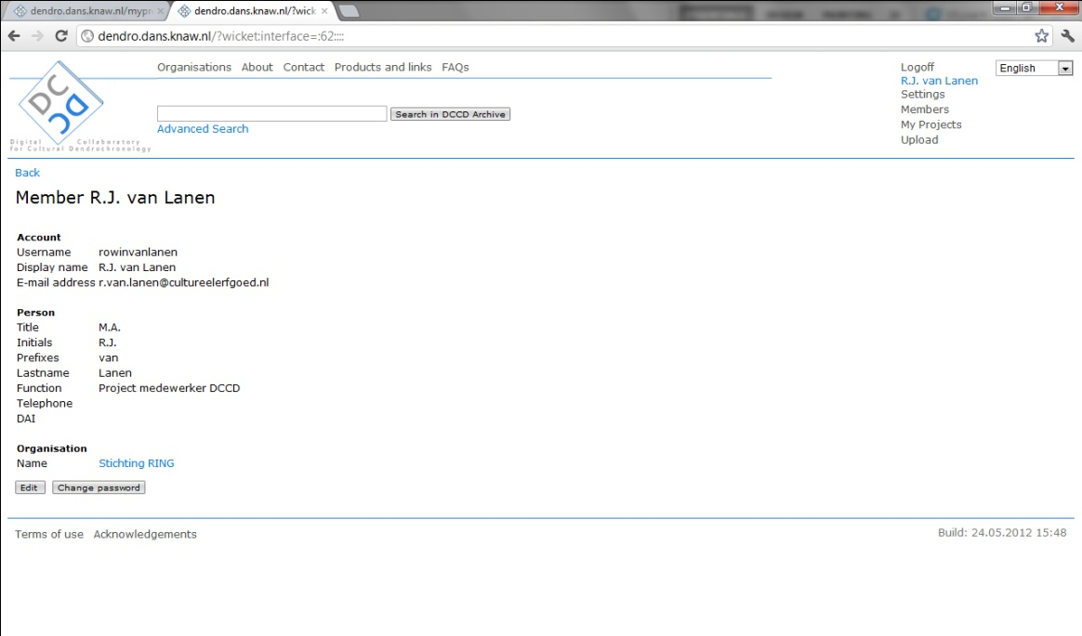

Clicking the “**edit**” button will open a page that is similar to the “registration” page, where alterations can be made:

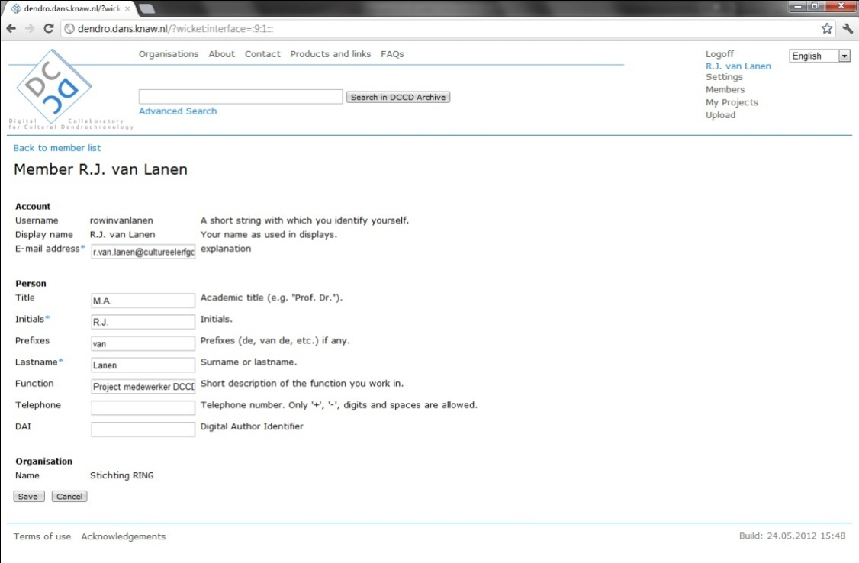

Members changing their password will see the screen depicted below. Simply change your password by typing your old password followed by the new password and a confirmation, and click “**save**”.

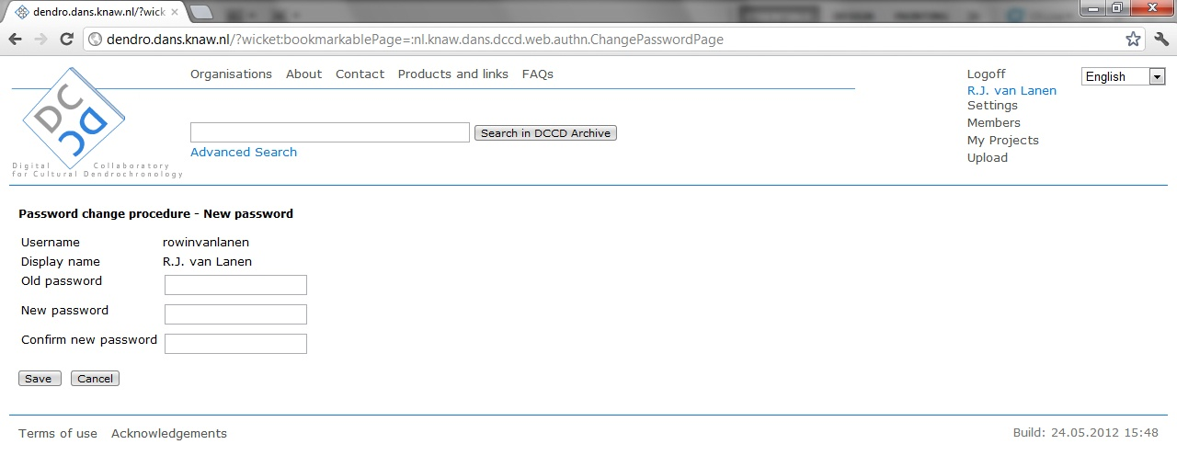

Uploading projects

The DCCD is fully TRiDaS compatible and only accepts metadata data stored in TRiDaS-XML. Uploading takes place in three steps: (a) uploading a TRiDaS metadata file (for example produced by the TRiDaBASE system; Jansma et al. 2012b); (b) uploading tree-ring value files specified in the uploaded metadata file (ring-width series, average series); (c) uploading associated files (e.g. research reports, photo’s).

*“Upload” page*

Members selecting the “**Upload**” link will see the following screen:

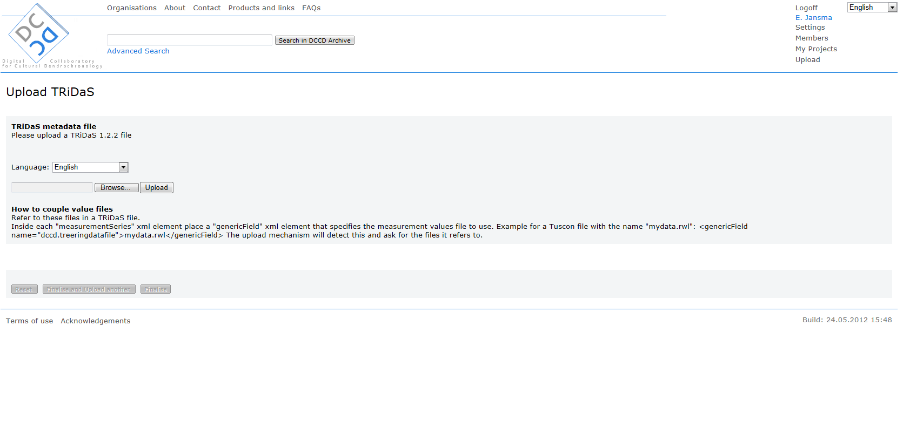

*Language setting*

Members should first select the language of the TRiDaS-XML file, in this example English. The DCCD verifies the metadata in the TRiDaS files against the selected language. If the TRiDaS file contains more than one language, or a language different from the specified language, the import of the TRiDaS file will fail (with the exception of the taxon field which is Latin at default). Note: the DCCD currently runs a language check on project/object/element type and project category.

*Selecting a TRiDaS-XML metadata file for uploading*

To select a TRiDaS metadata file for uploading, click on the “**Browse**” button and browse to file’s location on your computer or network. Locally select the file and click “**open**”. To upload the project click on the “**Upload**” button on the DCCD screen. Note: currently the DCCD only supports uploading a single TRiDaS project-metadata file at a time.

*Verification of metadata file structure and content*

During the upload process the DCCD checks the integrity of the TRiDaS-XML metadata file (e.g. version, XML structure) and the references in this file to associated files. Associated files can be videos, photos, research reports, measurement and/or derived series files, and should be referenced in the TRiDaS-XML by their full file name (name.extention). Files referenced in the TRiDaS-XML *have* to be uploaded before the uploading process can be completed.

*Uploading single tree-ring value files*

In the example shown below the uploaded TRiDaS metadata file refers to two value files (dbv00191.fh and dbv00192.fh). The first step now is to define the digital format of the value files. In this example both value files are Heidelberg format, therefore Heidelberg has to be selected from the pick list. Note: data formats supported by the DCCD are described by Brewer et al. (2011). Formats not in the pick list are not supported by the DCCD.

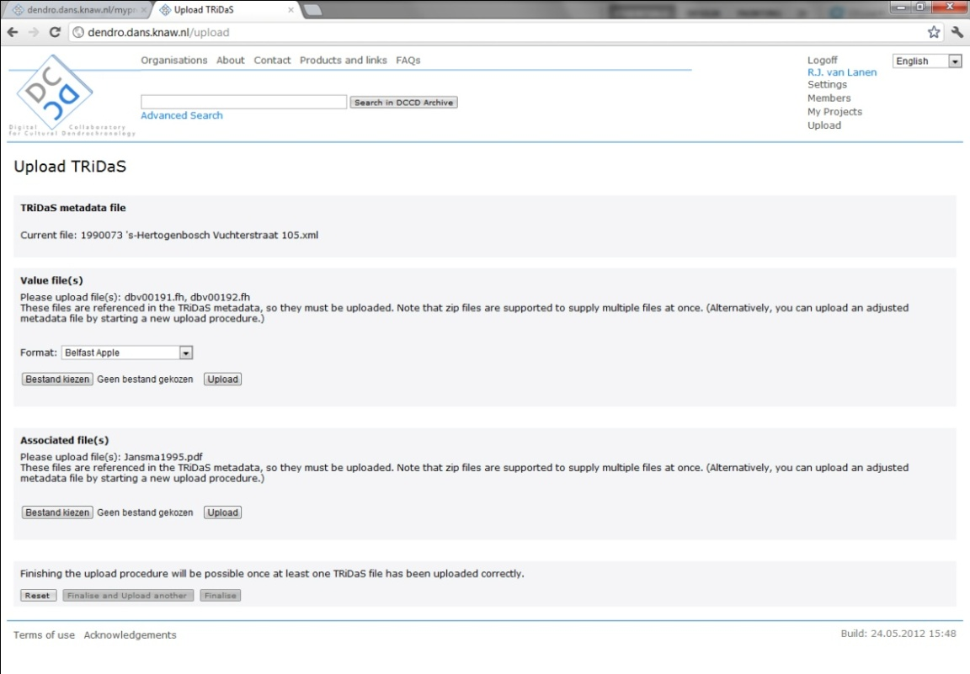

After selecting the type of value file (“**Bestand kiezen**” button in the screen depicted above) browse to the location of the value files in your PC or network. Select an individual file and click on “**Open**”, then click the “**Upload**” button. Repeat this process for every individual value file.

*Uploading single associated files*

The above figure lists one associated file (“Jansma1995.pfd”). In order to upload associated files: Click on “**Choose file**” (“bestand kiezen”) and browse to the location of the referred file on your PC or network. Select the file and click “**open**”, then click the “**Upload**” button.

*Uploading multiple value/associated files*

In order to upload large collections of value files or associated files, store the intended files in a compressed folder on your PC or network. In the DCCD select the compressed folder and click on “**Upload**”. The DCCD will search in the compressed folder for all individual files. Note: do *not* mix value files and associated files in a single compressed folder, but make one separate compressed folder for value files and a second compressed folder for associated files. When all value files and associated files are uploaded, click the “**Finalise**” or the “**Finalise and upload another**” button to finish the upload process.

*“Finalize” button*

The “Finalise” button will conclude the upload process and opens **MyProjects** (see ‘“My Projects” environment’).

*“Finalize and upload another” button*

Clicking on the “Finalise and upload another” button will conclude the upload process and start a new upload process.

*“Reset” button*

The “reset” button is always visible on the Upload screen. If you press it the DCCD will discard all uploaded files and will reset the upload process. Note: the user will have to define the project language and value-file type again before the upload process can start again.

Draft projects

*“My Projects” environment*

Finishing the uploading process stores the uploaded project in your personal “**My Projects**” section of the DCCD. Here the uploaded project has a draft status. In the “My Projects” environment DCCD-members can edit draft projects and view the projects they already archived. Draft projects have not been stored in the DCCD repository yet and as a result remain invisible to all other users of the DCCD. In order to archive a project you have to select this project in “MyProjects” and click on the “**Archive**” button (see below).

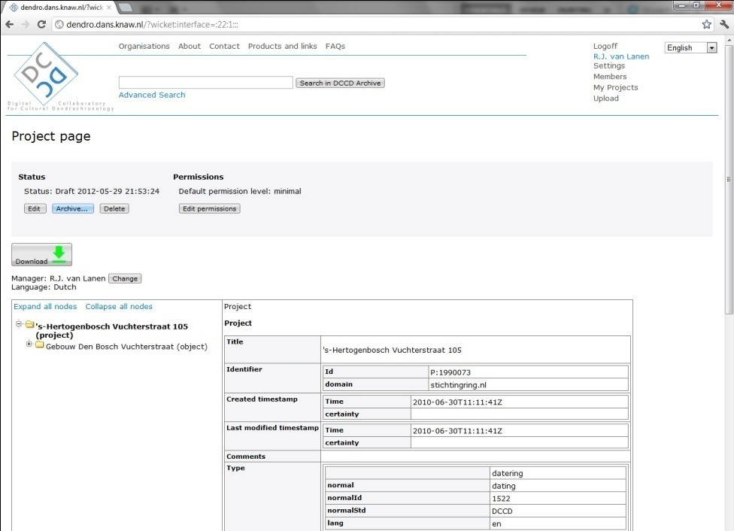

*Editing draft projects*

The content of draft projects can be edited by clicking on the title of the preferred project and next clicking on the “**Edit**” button placed to the left of the “Archive” button. Note: it is currently impossible in the DCCD to add new value files, associated files and TRiDaS levels to a project structure. If you wish to add these, you need to download the project from the DCCD, import it in TRiDaBASE or another TRiDaS-based program, add levels and/or references to files, export the file to TRiDaS-XML and upload it again to the DCCD.

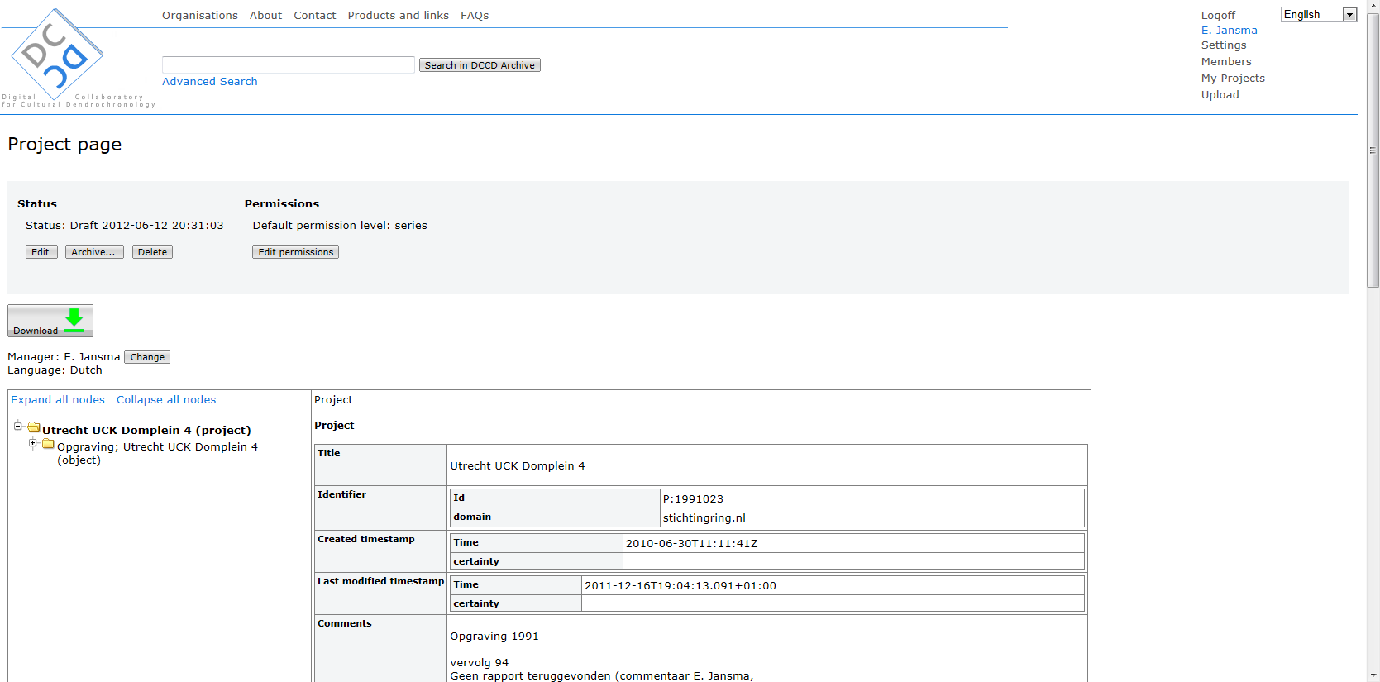

In the edit mode you should select a TRiDaS level (e.g. project, object, element, sample) in the left side of the screen. This opens up the related information level, which becomes visible on the right side of the screen. Next on the right side of the screen place the cursor on the field you wish to edit, and add/edit information. The red **X** at the right of data fields will delete all information in this field, and will be replaced by a green + that allows you to enter new information. To save the edited project click on the “**Save**” button situated on the top and the bottom part of the (right-side) screen.

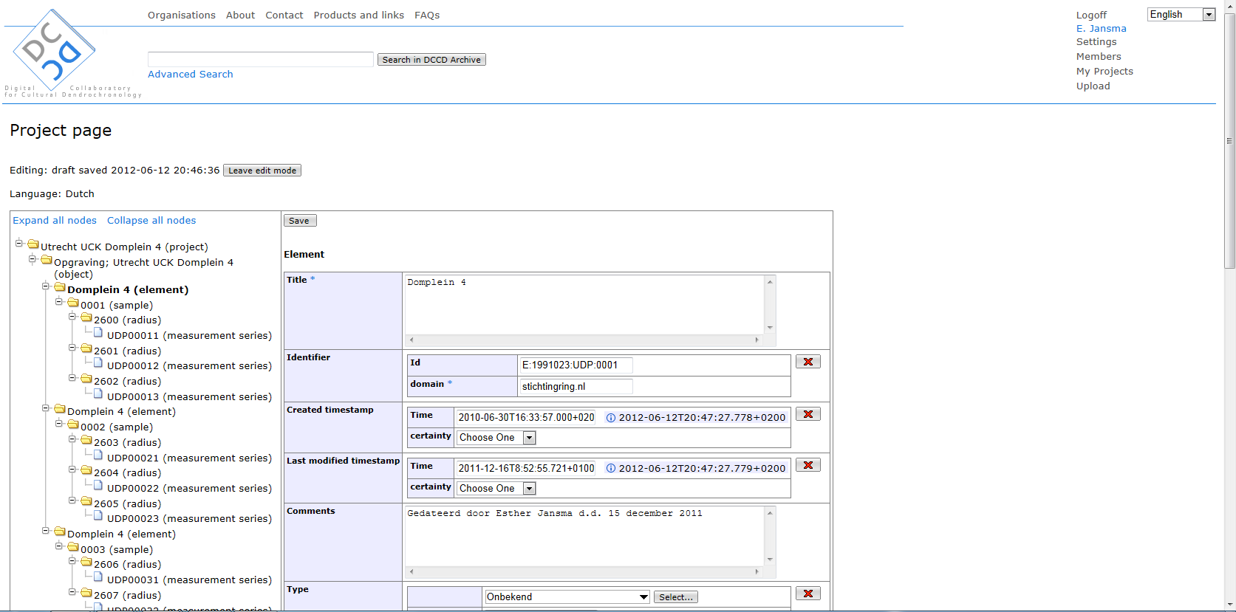

*Editing draft projects: checking for errors*

In the edit mode the content of a project is checked against the requirements of TRiDaS and the DCCD. Errors and inconsistencies are reported by an exclamation mark (“**!**”) in front of the TRiDaS level shown in the TRiDaS information tree to the left of the screen. When saving changes to an edited TRiDaS level, in case of errors red warning messages will appear on top of the right side of the screen.

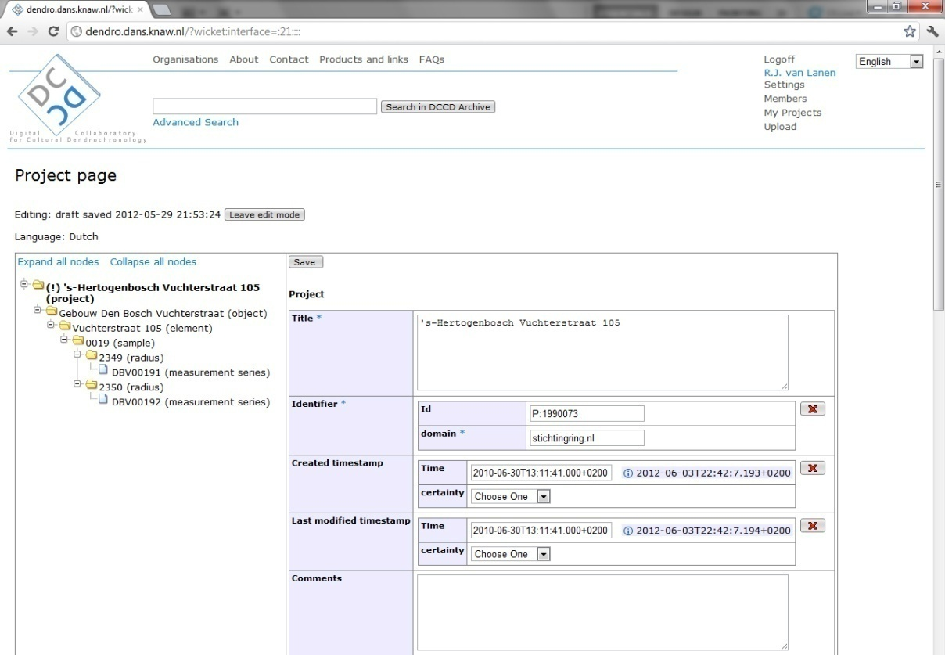

*Leave edit mode*

When members are done editing and have saved all their changes, they need to press the “Leave edit mode” button. To archive the project, follow the steps described under “Archiving projects”.

*Adding additional associated files*

When a project is in Draft mode you can add additional associated files. This is useful if you have found important extra information that you want to add to an already uploaded project. In order to add these ‘new’ files select the “**Add**” button next to the Associated files in the project view.

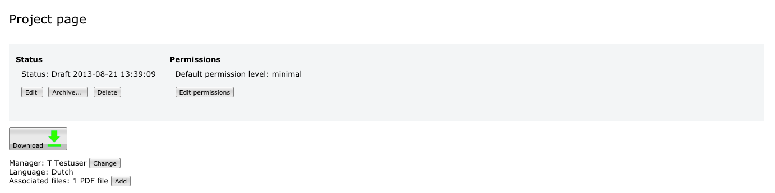

This will show the “Upload Additional Associated Files Page”.

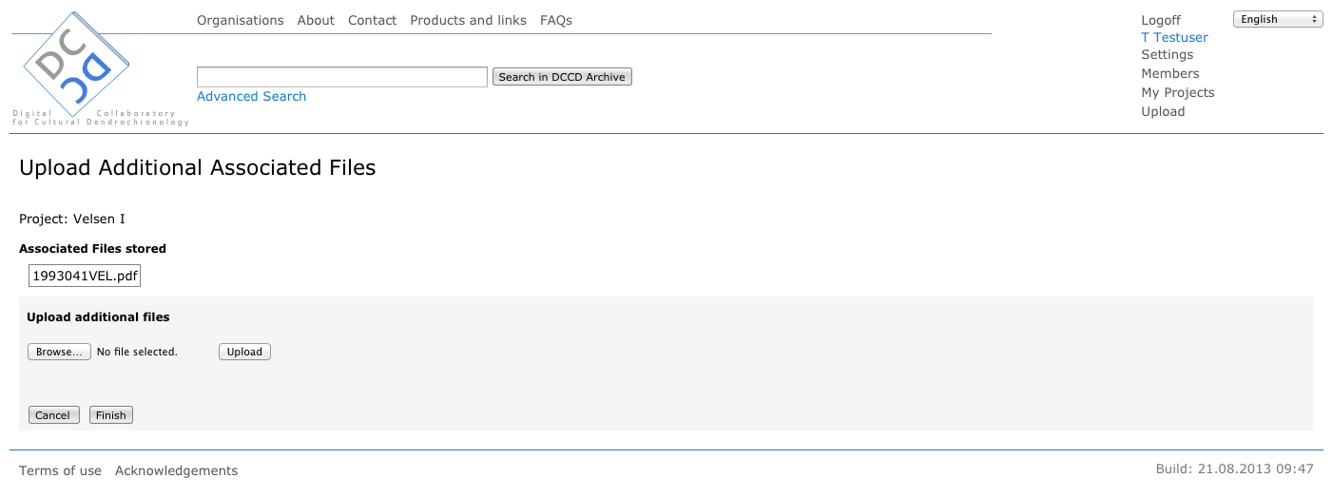

Using the “**Browse**” button allows you to specify a file that can then be uploaded with the “**Upload**” button.

Uploading can be repeated to add multiple files and also compressed (zip) files can be uploaded to add all files in it. The files uploaded are listed above the upload controls. An uploaded file is discarded for adding if it has the same filename as an already uploaded or stored file. The filename comparison is done without regarding case; so notes.txt is equal to Notes.TXT.

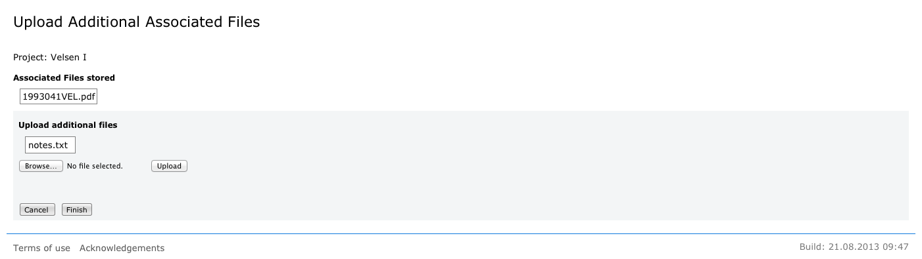

When done with uploading the “**Finish**” button will make the changes to the project, add the files to the archive and bring you back to the updated project view page. Note that if you have no files ready for adding the Finish button will do nothing and you can to push the “**Cancel**” button to go back to the project view.

Archiving projects

If the uploaded TRiDaS metadata file is not compatible with the requirements of the DCCD, this will be reported during the archiving process. Errors have to be corrected before archiving can be completed, using the DCCDs “**Edit**” function (see “Editing draft projects: checking for errors”).

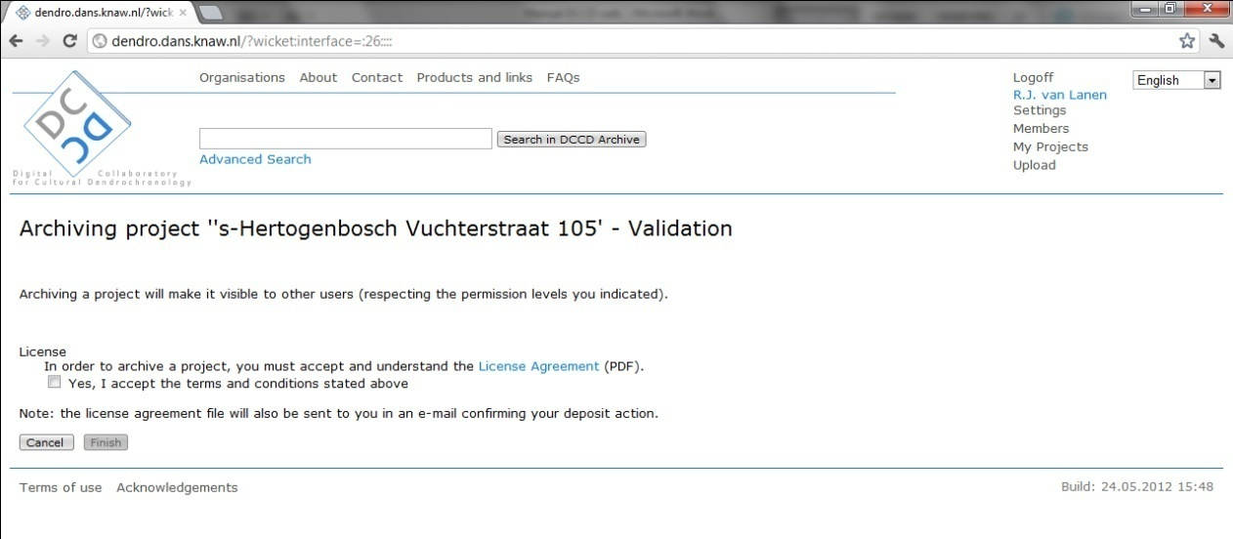

Before a project can be archived, you need to accept the terms and conditions stated in the “**License Agreement**”. The [content of the DCCD’s Licence Agreement](http://vkc.library.uu.nl/vkc/dendrochronology/SiteCollectionDocuments/Legal%20documents%20DANS/Licence%20Agreement%20DANS.pdf) is shown online during the archiving process and is also available through the VKC for Dendrochonology. Clicking on the “**Finish**” button will archive the selected project. You will receive an automated mail from the DCCD confirming your data deposition.

Unarchiving projects

Archived projects can be ‘unarchived’ by their owners in order to improve the projects content. This option, which removes a project from the DCCD repository and provides it with a draft status, will be replaced in the future by functionality that allows storage of different project versions.

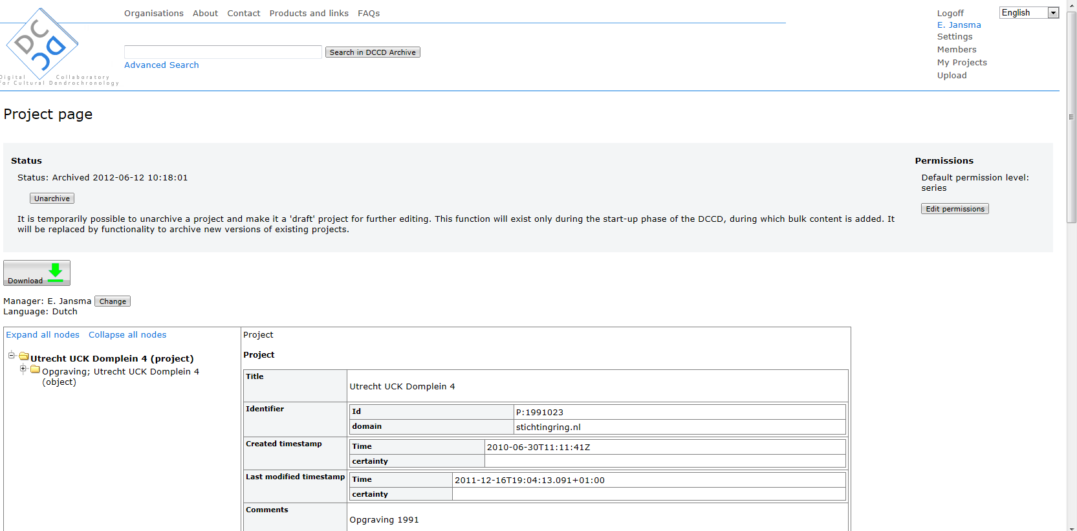

Viewing projects

The content of projects can be viewed in detail by clicking on the title of the preferred project. On the left side of the screen the content of the selected project will become visible according to its TRiDaS-based information levels. Members can expand the visible levels by clicking on the “+” button, and collapse levels by clicking on the “-“ button. The “**Expand all nodes**” button on the top of this section will expand all information levels. Clicking on “**Collapse all nodes**” will collapse the TRiDaS information tree to the default situation.



Data-access permission levels

A projects permission level determines to which level other DCCD members can view or query your data.

The permission levels of the DCCD are hierarchically structured following TRiDaS.

*“Maximum security” access level*

Projects stored in the DCCD automatically are assigned a ‘**maximum security**’ status, meaning that only public metadata are open for viewing. The public metadata are:

* Project title: the human-readable title under which a project is stored;
* Research context (project type): e.g., anthropology, climatology, dating, ecology;
* Principal investigator: the scientist responsible for the project's content;
* The period in which the research took place: year/month/day, or estimation;
* Physical context of the material: e.g. archaeology, built heritage, furniture;
* Laboratory: name of the laboratory that produced the data;
* Object title: the human-readable title given to the studied object(s) in a project.

When a project has “maximum security” status, it means that public metadata is shown and can be searched while all other content is inaccessible except for the data owner.

*Project to Series permission levels*

Setting permission levels to one of these TRiDaS levels means that this level *and all levels placed above it* are visible and can be queried, with the exception of fields containing privacy-sensitive information.

**Object level**: in this level the coordinates of your study objects are stored. If you want this project to show up on the DCCD map, you need to unlock your project to this level.

**Element level:** this level contains the tree species you have studied in a project. If you want your project to be found during species-related queries, you need to unlock your project to this level.

**Series level**: this level contains the dates and (if you have registered provenance) the growth regions of the wood you studied. If you want your project to be found during chronological and provenance-related queries, you need to unlock your project to this level. Opening your project to this level means that all *metadata* of your project can be fully searched, while the data itself (the actual time series) remain invisible.

*“Values”* permission level

If a projects permission level is set to “Values” level, the project can be downloaded including its value files and associated files (see under “Downloading DCCD projects”).

Setting data-access permission levels

DCCD data managers can set and alter permission levels for archived and draft projects alike. To alter permission levels go to “**My Projects**”, select a project and click on the “**Edit permissions**” button. This will enable you to (re)define default project permissions (which will apply for all DCCD users) and alternative permissions for selected individual DCCD members.



*Setting the default permission level*

The default permission level of a project defines the accessibility of a project within the DCCD for all DCCD members. To set the default permission level, click on the “**Default permission level**” button. This opens op a new screen containing the permission pick list.

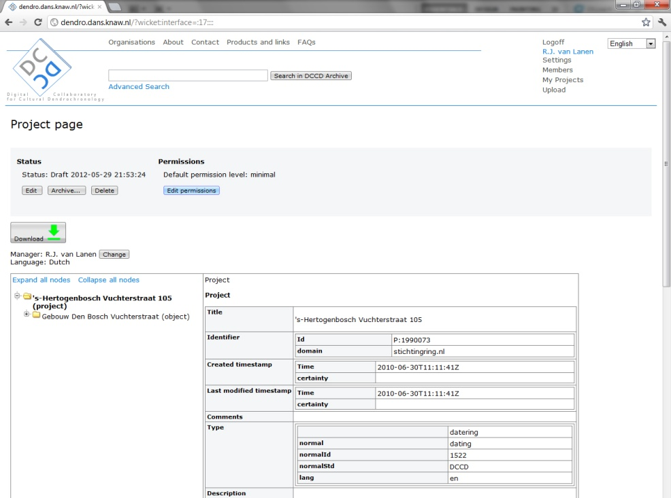

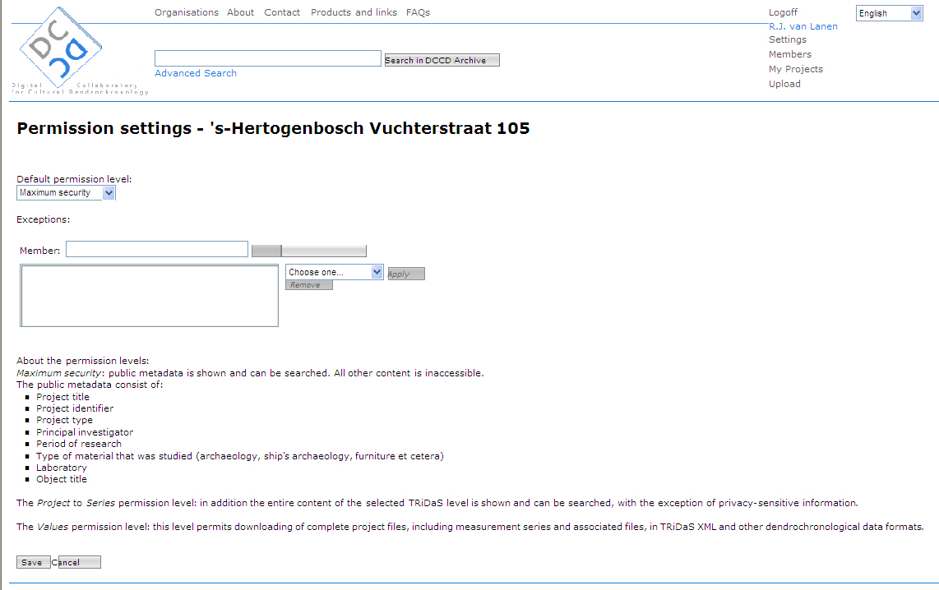

*Setting alternative permission levels*

Adapting the permission level of a project for individual DCCD members is done by pressing the “**Show all users**” button and selecting individual members by pressing on the “**add**” button. Members can also be selected by entering the first digits of usernames in the “**Member**” field.

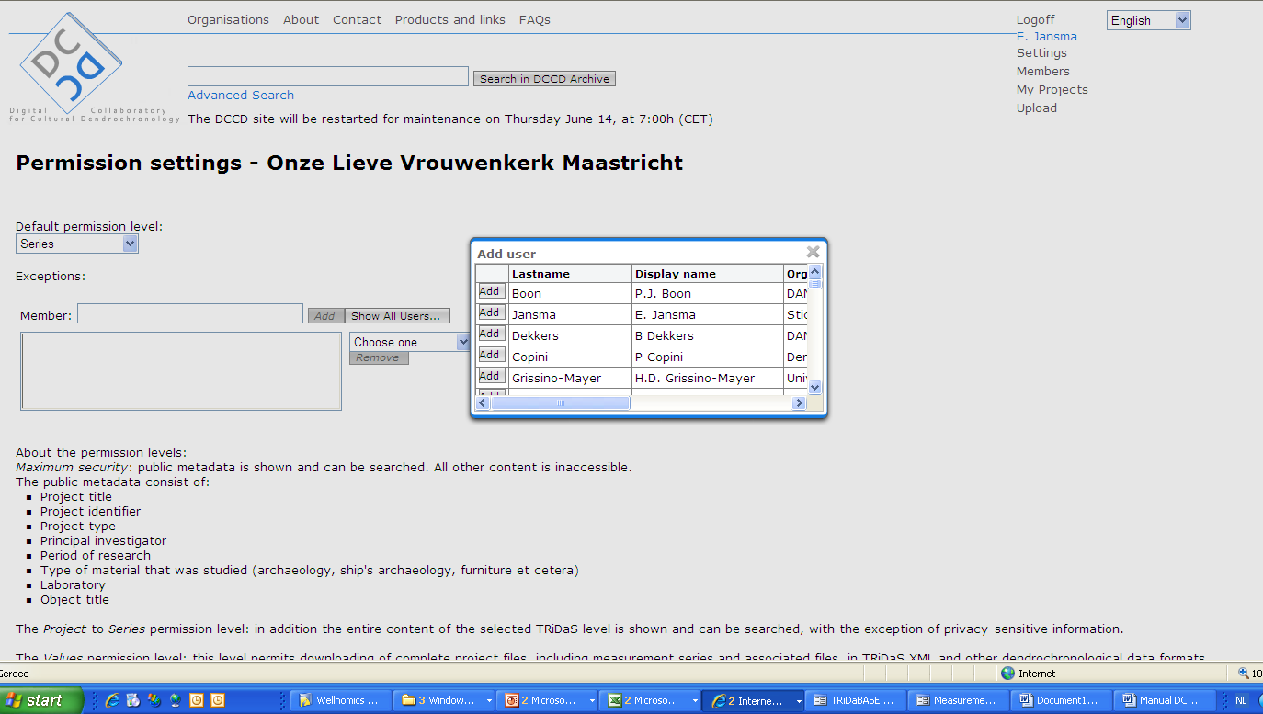

The names of selected DCCD members will appear directly below the “Member” field. To continue, the screen “Add user” should be closed by pressing the “X” on its top right side.

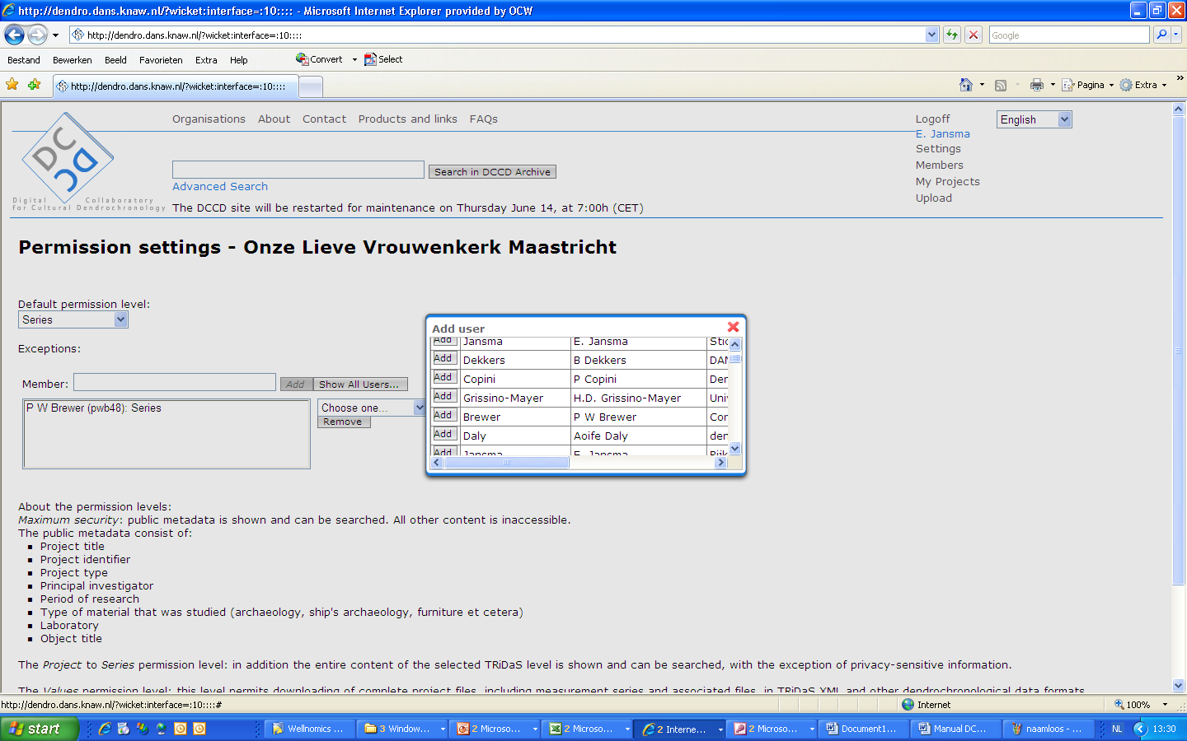To set permissions for the selected user or group of users, please follow the following three steps: (1) select the users by double-clicking on their name, (2) select permission level in the permission-level pick list, and (3) press the “**Apply**” button.

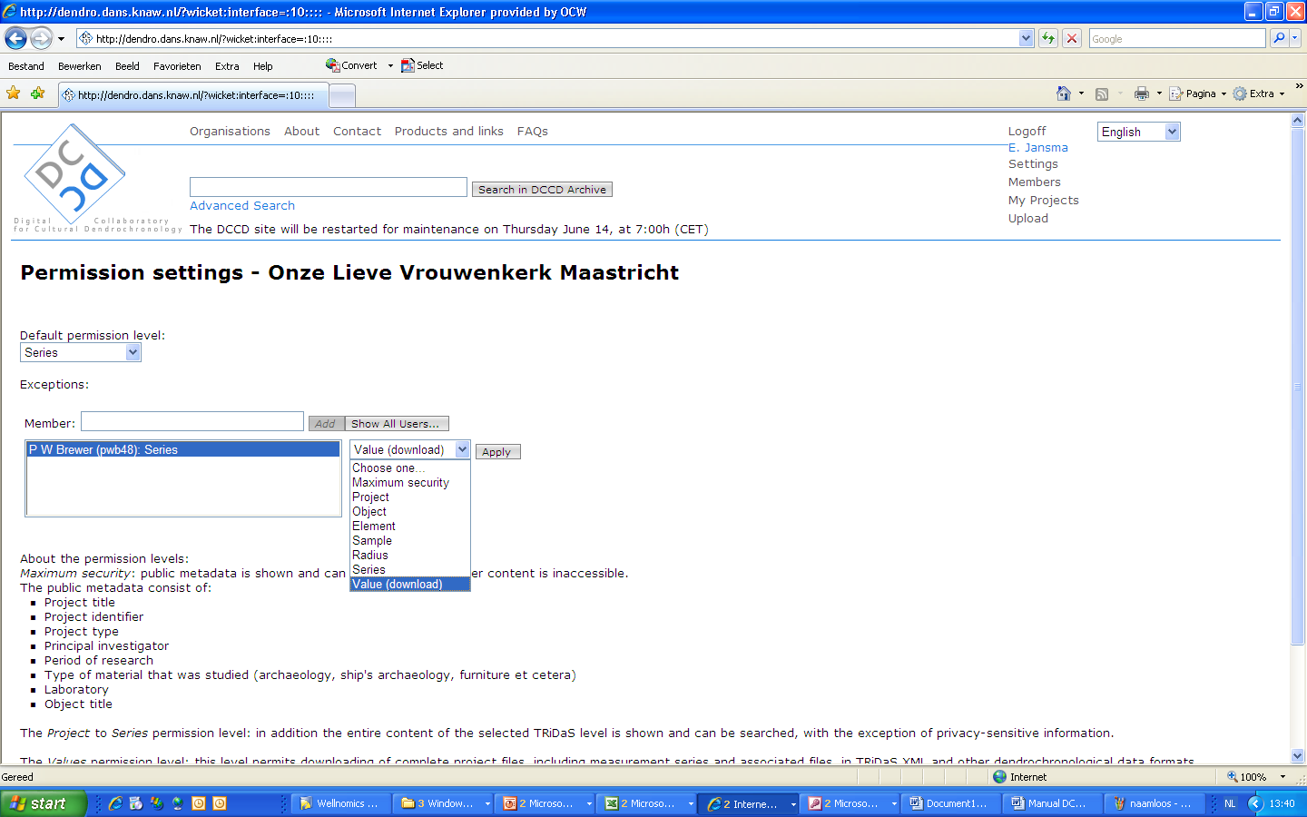

Changing data managers

Manager permissions can be altered by the current data manager of the project. Because data owners and managers can change over time, the current manager of a project can assign the management rights of this project to another member of the same organization. To change the data manager, select a project in “**My Projects**” and click on the “**Change**” button.

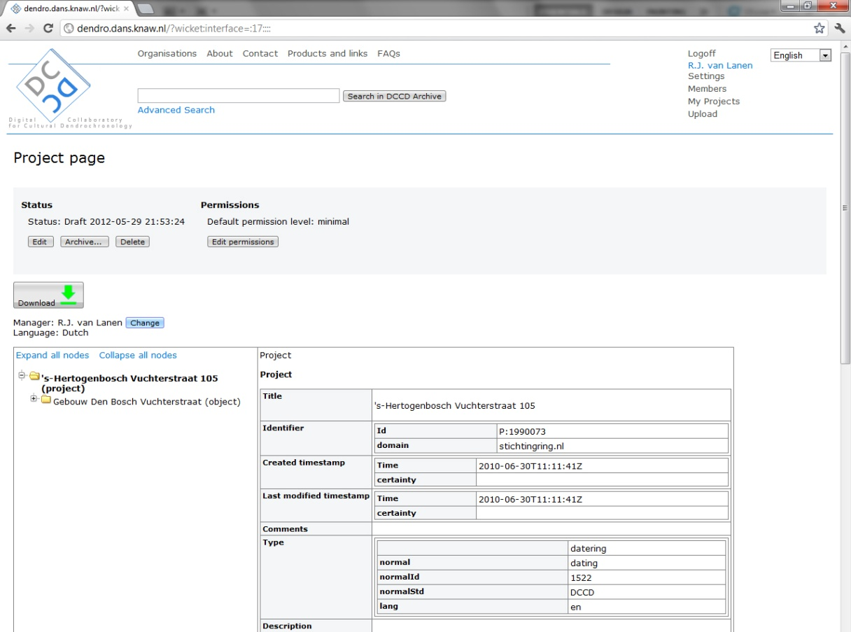

The current manager of the project is displayed underneath the download button (in this example the manager is: “R.J. van Lanen”). Enter the name of the new manager into the “**New manager**” field and select this name (in this example: “Prof. Dr. E. Jansma”). Finish the process with “**Save**”. Note: new managers need to be from the same organization as the original data manager, in order to prevent that data ownership is transferred between organizations. If data ownership does need to be transferred to another organization, DANS will create a “backdoor” solution. In that case please contact the DCCD project manager.

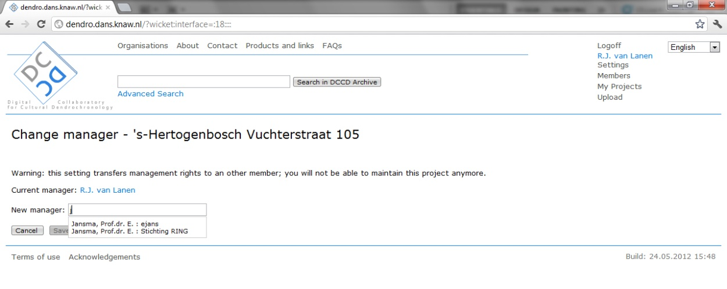

Querying the DCCD repository

A query searches all fields that are indexed by the DCCD and that are unlocked by the permission levels of the projects. Entering a term such as “water well” in Dutch will also include English, French and German equivalents into the query-result list. The reason is that the DCCD repository uses a multilingual approach towards the following information: (a) **project category** (e.g., “archaeology”, “built heritage”; (b) **Object type** (e.g., “water well”, “farm house”); and (c) **Element type** (e.g., “pile”, “stave”). Currently the DCCD supports Dutch, English, French and German. Note for DCCD data managers: location coordinates in TRiDaS are stored on the object and element level. Settings permission level of a project to the element level ensures complete spatial visibility of the objects and elements this project contains.

*General search*

A general query is performed using the search bar and the “Search” button. This results in a paginated overview projects (10 projects/page) and a geographical overview of the listed projects on a map to the right or the screen.

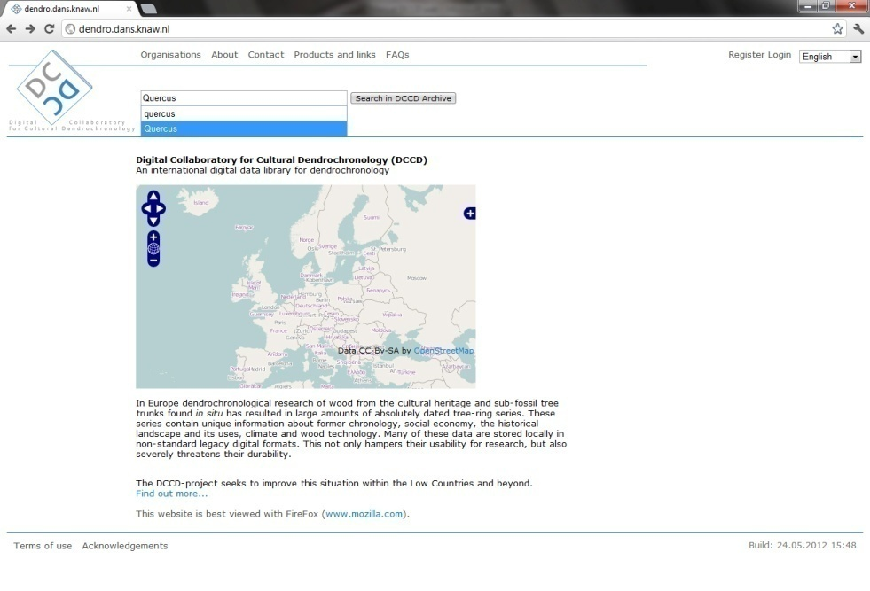

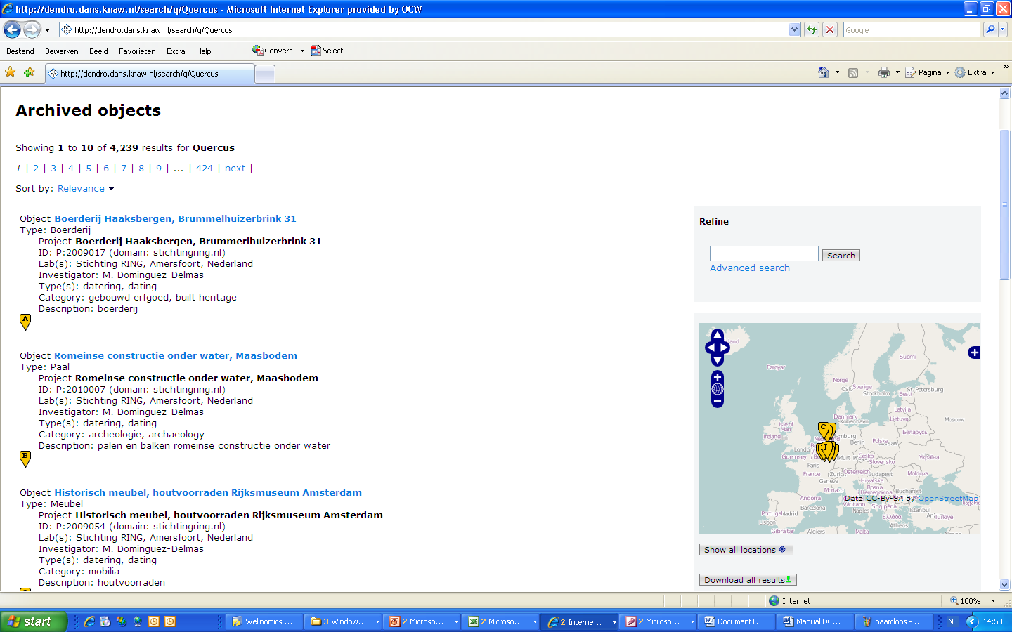

*Setting the number of results per page*

Search result lists are shown with 10 results per page by default, but you can change the value using the drop down list next to the page indicator. The selection you make will be used for all types of search results and also for the list of projects on the "My Projects" page. Only after half an hour of inactivity the value will be reset to the default.   
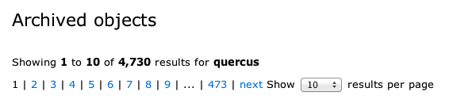

*Viewing a result*

Clicking on a specific project will open the project and will present its content according to the levels of TRiDaS. If a user clicks on a level that is not assessable due to its current permission levels, a screen appears telling the user that the requested information is shielded and providing the e-mail address of the current data manager (“P. Copini” in the example below).

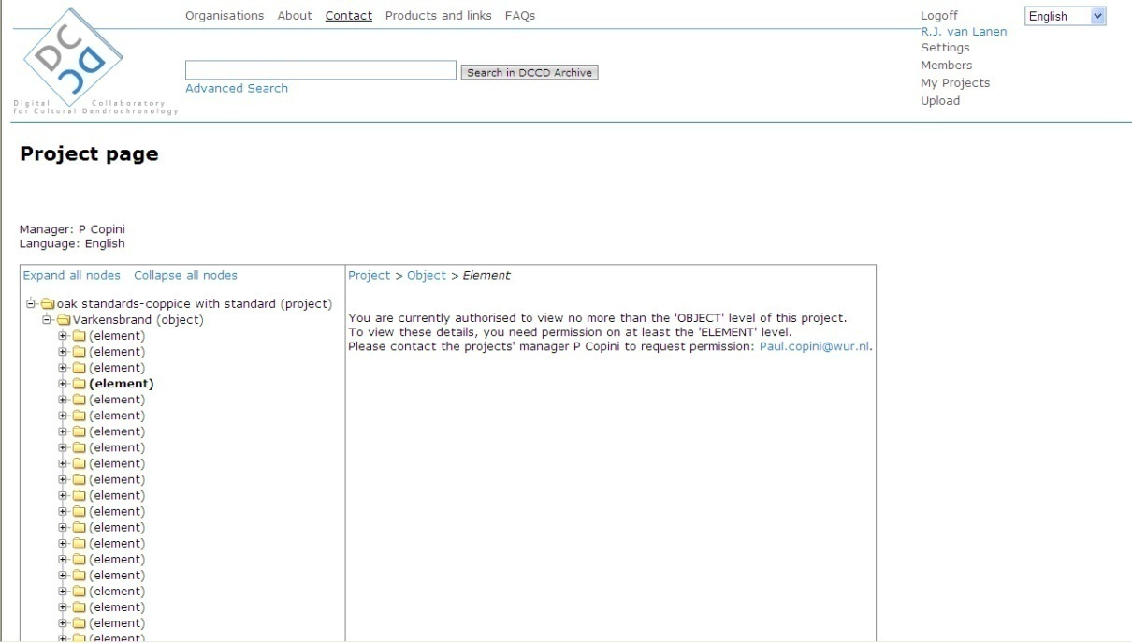

*Advanced search*

The “advanced search” option is only available for members logged into the DCCD. Logged-in members see the “Advanced Search” on the DCCD homepage.

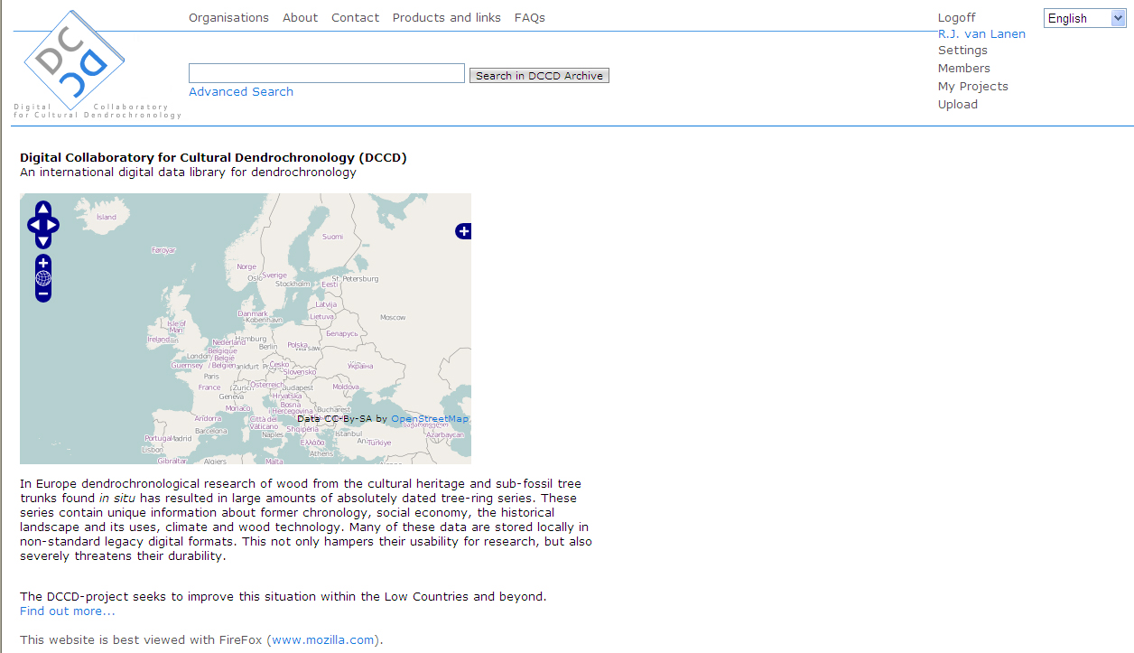

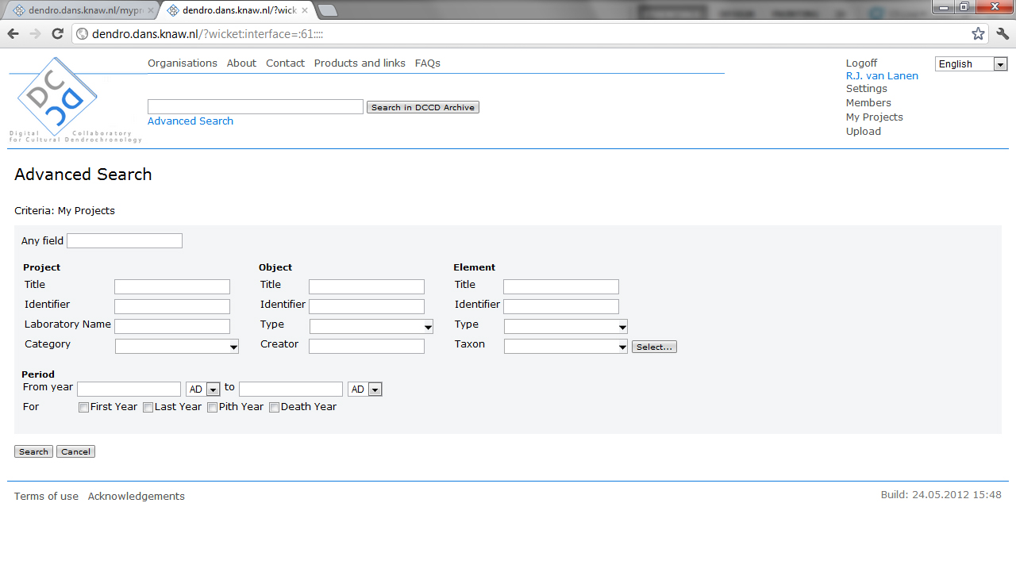Clicking on the “Advanced Search” field will open the “advanced-search” page, allowings member to perform advanced queries for combinations of predefined information fields. The “Advanced Search” page is divided in TRiDaS levels “Project”, “Object” and “Element”. **Project category**, **Object type**, **Element type** and **Element taxon** are part of the controlled vocabulary if the DCCD and can only be queried using the pick list. Note: depending on your system opening these pick lists may take time.

In addition a free search field is visible which will accept all terms and will search all fields in the DCCD index. Members can also perform period searches on “First Year”, “Last Year”, ”Pith Year”, and “Death Year”.



If members wish to refine their search results further (either after a general or after an advanced search), they can use the refine section above the map on the right side of their screen. Clicking the “**Advanced search**” on the right side of the screen will reopen the same “**Advanced Search**” page and will add a query variable to the result page.

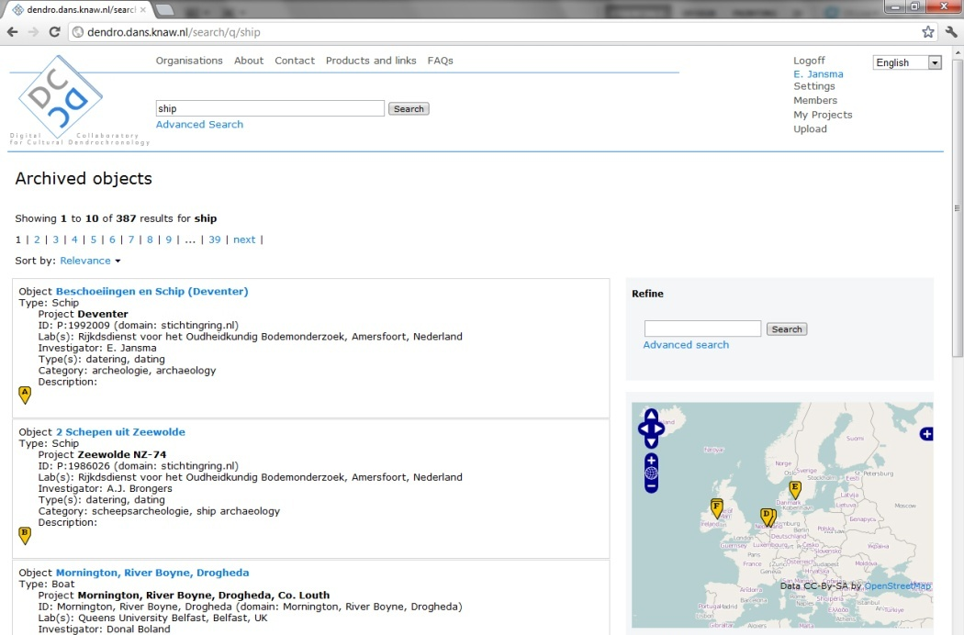

*Spatially mapping query results*

Query results are spatially shown using the DCCD maps. The smaller map to the right of the screen displays paginated search results, with a maximum of 10 projects. To get a full spatial overview of all query results users should click the “**Show all locations**” button placed below the smaller map. This opens a new page with a larger map depicting all search results (in this example 402 results for a query on the Dutch term “Schip” (equivalent of the English term “ship”).

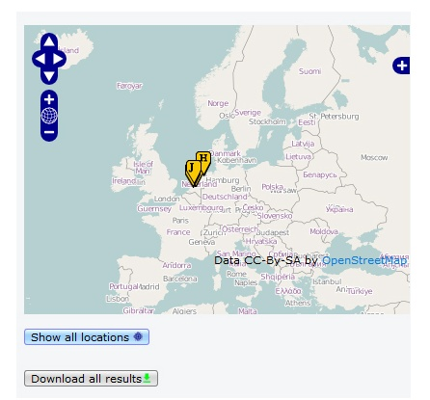

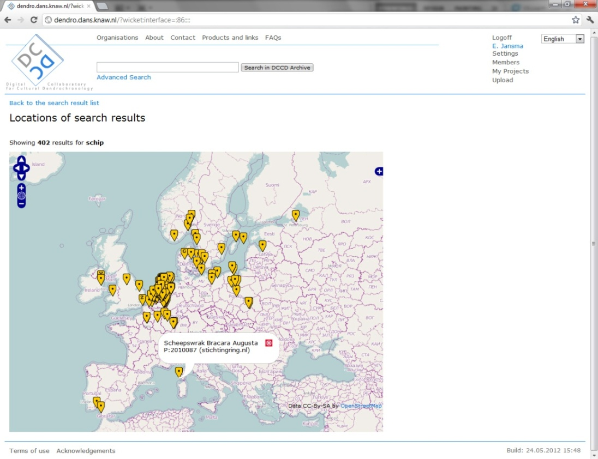Clicking on an individual label on the map will provide information on a specific object including identifiers and domain. Members wanting more information about this project can search the project identifier and domain and open (or download) the project. Note: depending on the size of the query (number of objects) and the internet connection, loading the larger map may take some time. Also note: a fast way to access a specific project is to copy label content, paste it into the “Search” field above the map and click on the “Search” button.

*Downloading query results in XML*

The DCCD allows members to quickly download an overview of search results. After querying the repository results are displayed in a paginated list of projects and on a smaller map to the right of the screen. To download query results members should click on the “**Download all results**” button placed below the map underneath the “Show all locations” button.

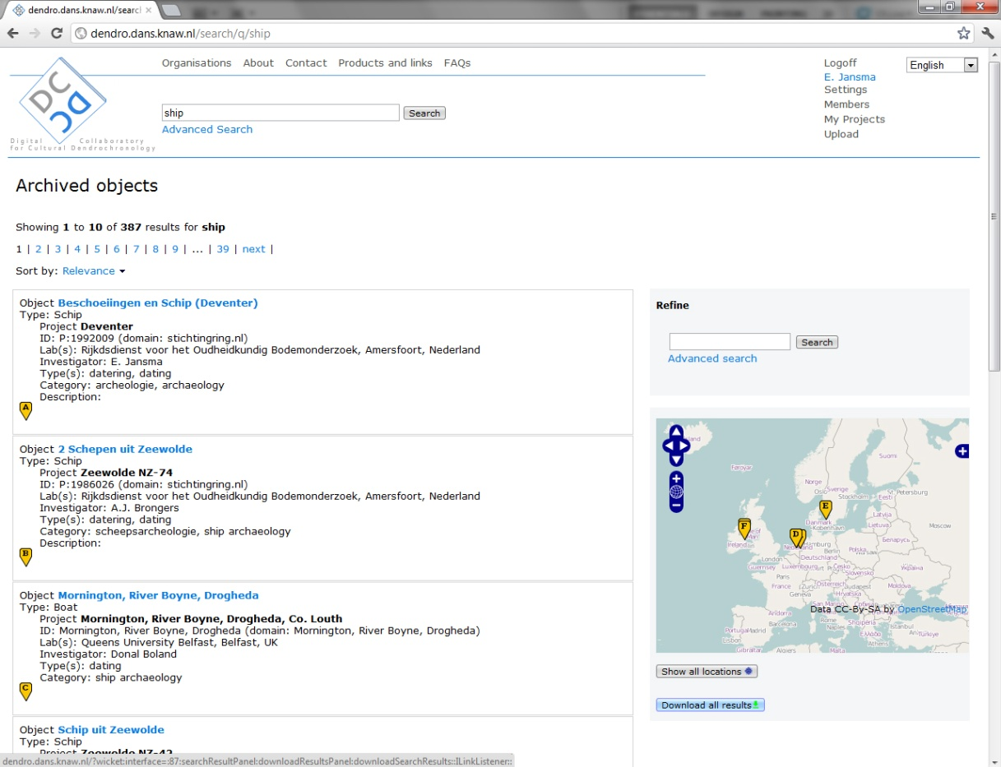

Clicking on the “Download all results” button results in a compilation of results into an single XML file. Depending on the number of projects the compilation may take a while. To continue, click the “**Start collecting the data**” button.

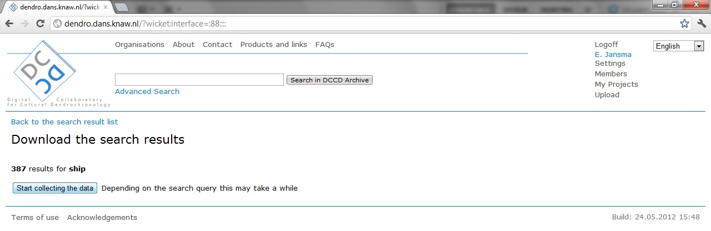

When the data have been collected a large “**Download all results**” button will appear. Click on this button and select a location where the XML file should be saved on your PC or network.

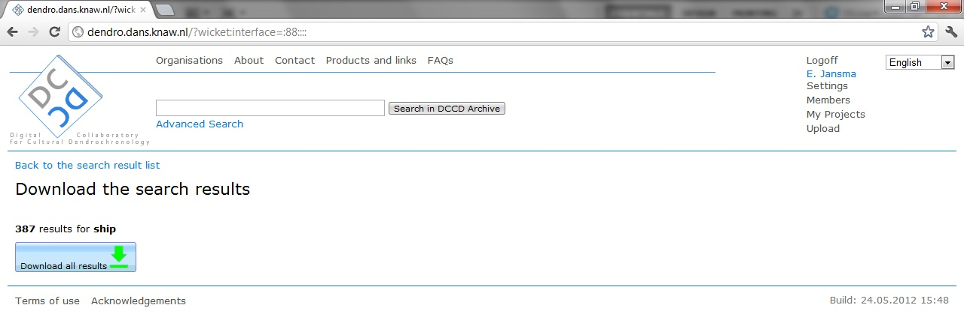

The DCCD will compile a file with the default name “*dccdsearchresults.XML*”. When saving the file to disk it is possible to enter an alternative filename.

*Opening an XML file containing DCCD query results*

The content of query-result files can be read into Microsoft Excel. There are two ways of doing this: (a) right-click on the file and open with Microsoft Excel; (b) start Microsoft Excel and open the XML file. The following message will appear. Note: the displayed language of this message depends on the language settings in Microsoft Office. In the example below the language setting is Dutch.

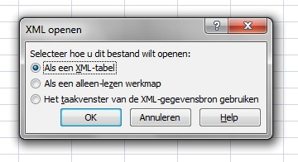

Users should always select the top option “Als een XML-tabel” (“Open like XML table”).

In some occasions users will also see the message depicted below, which states that Excel will make a schema based on the imported XML. Users can check the box to never display this message again and select “**ok**”. The file with DCCD query results is then imported into Excel.

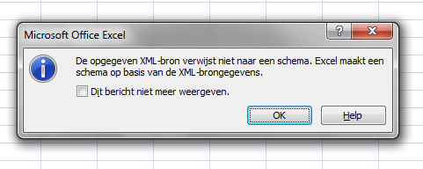

The resulting spreadsheet shows one single object per line (columns D and E) and for projects containing > 1 object repeats the project information listed in columns A-C. Its displays additional information in various rows (F-N).

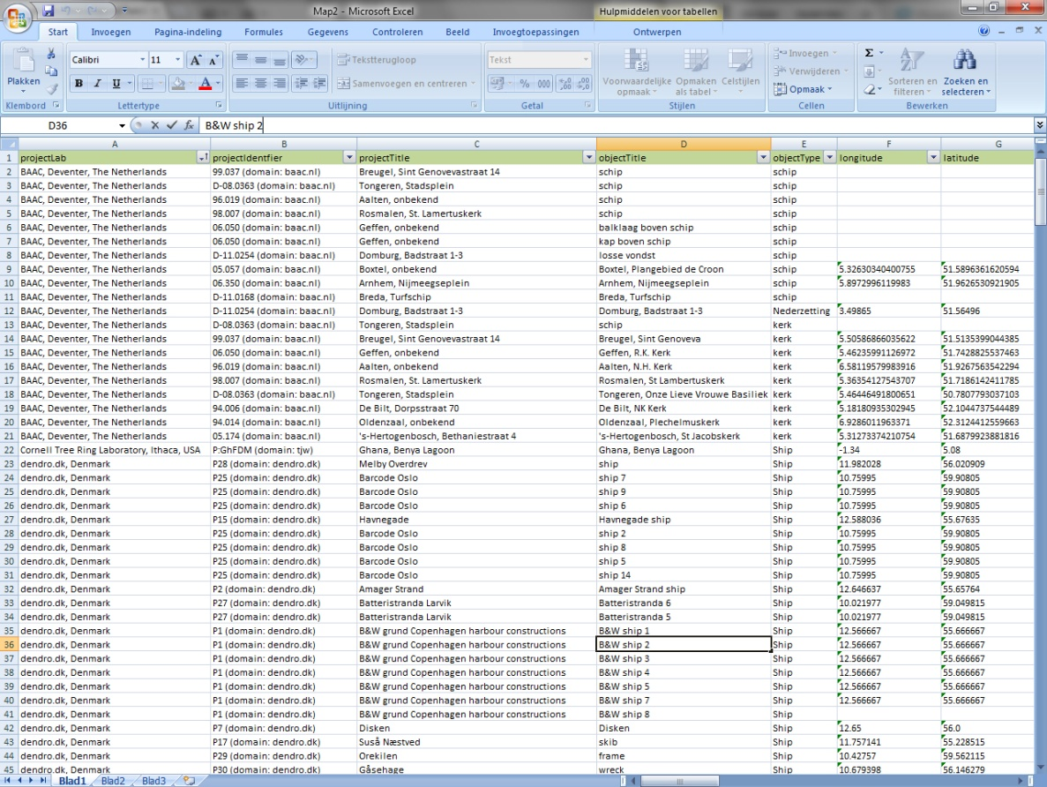

Spreadsheets containing DCCD query results contain the following fields:

|  |  |
| --- | --- |
| **TRiDaS Level** | **TRiDaS data field** |
| Project | Laboratory |
| Identifier |
| Title |
| Object | Title |
| Type |
| Longitude |
| Latitude |
| Element | Title |
| Type |
| Taxon |
| MeasurementSeries | First Year |
| Last Year |
| Pith Year |
| Death Year |

Downloading DCCD projects

DCCD members can download their own projects and projects by others who have set the permission level to the Values level of TRiDaS. After querying the repository a list of projects is displayed meeting the query variables. Clicking on a project will open the project on a next page. If members are allowed to download the project, a large “**download**” button will be displayed.

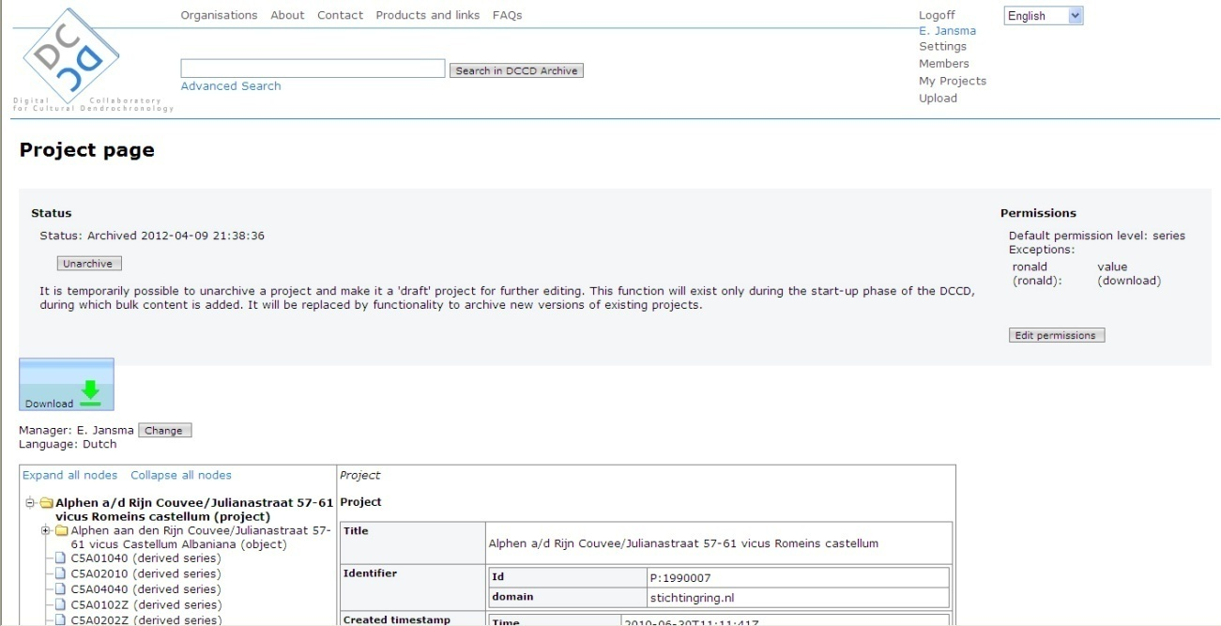

To download a project, click on the “**Download**” button. The following page will appear:

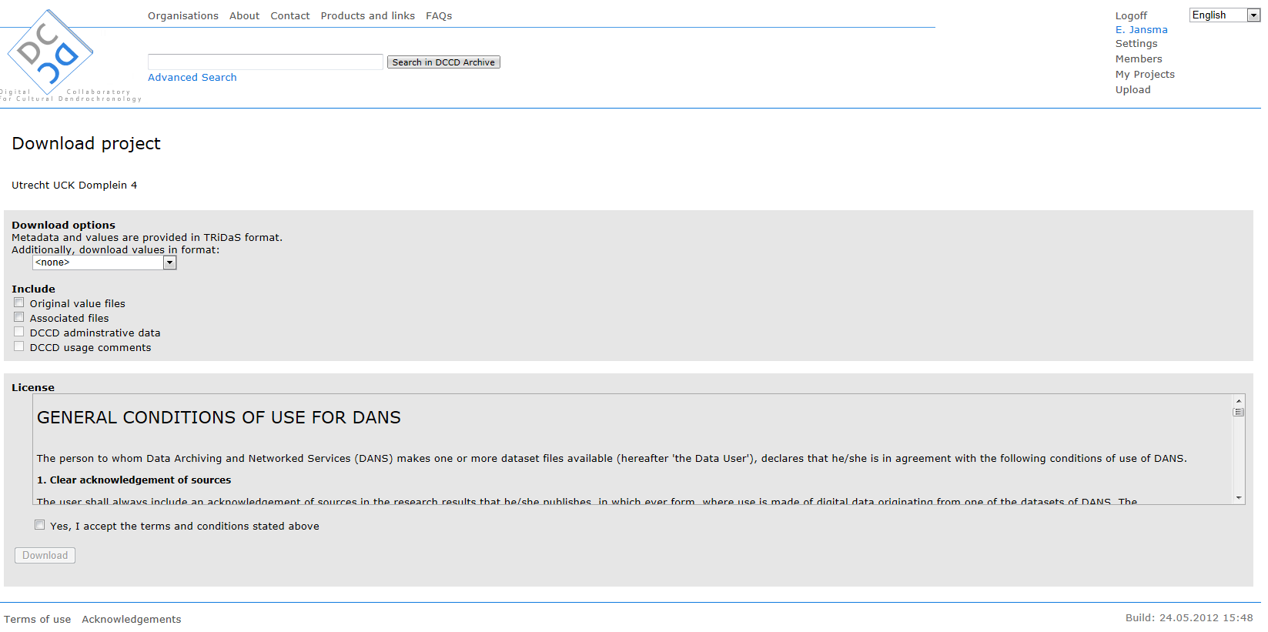

The next step is to determine what files are to be downloaded. Options to this effect are shown on the same screen.

*Minimum download*

In all cases the requested project file is downloaded in TRiDaS format with metadata and data integrated into a single XML file.

*Downloading original value files*

Ticking the box “Original value files” will add the originally uploaded series. These can have any format (e.g., Tucson, Heidelberg, Besancon).

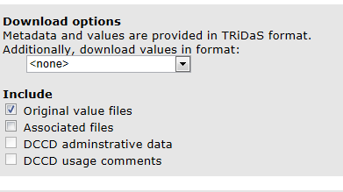

*Downloading additional value files*

Selecting an additional value-file format will add the series in the format specified by the user. These are most of the formats incorporated into the data-conversion library TRiCYCLE (Brewer et al 2011). Note: some data conversions may need to be improved further, please communicate your findings using the TRiDaS discussion forum (<http://tridas.org/forum/>).

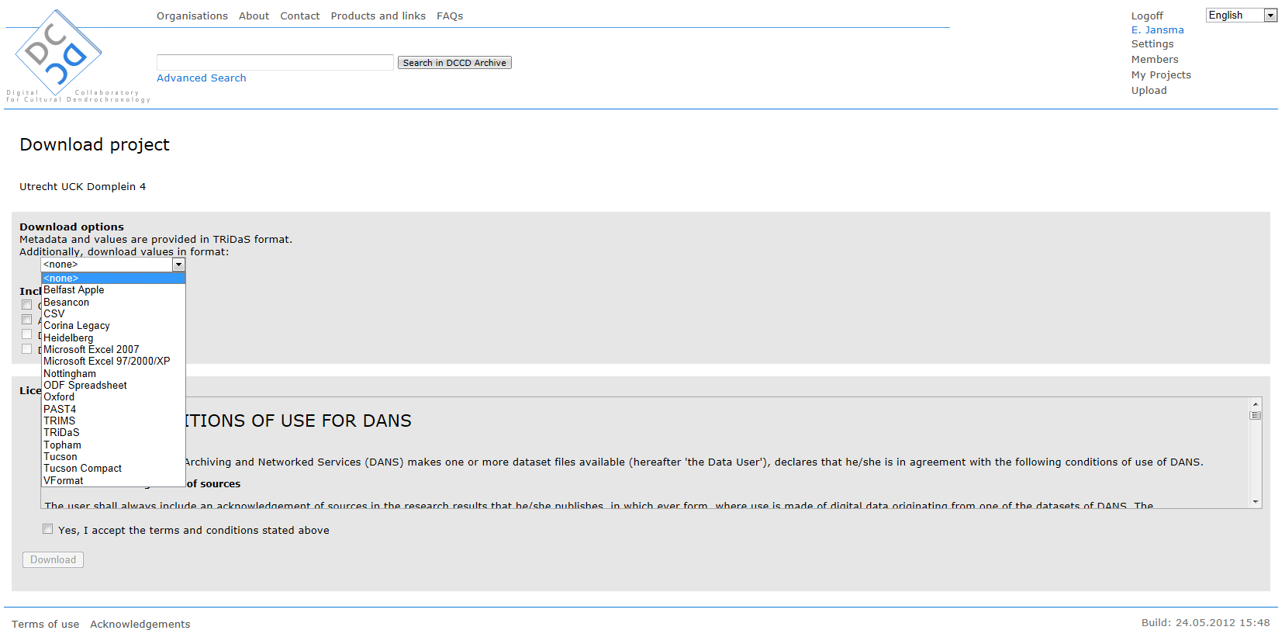

*Downloading associated files*

Associated files are non-value files incorporated into a project. These can be research reports, Excel files containing analytical results and overviews, publications, photo’s, et cetera. To download associated files, activate the “associated files” tick box.

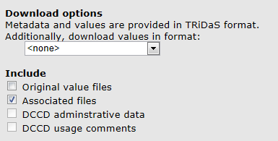

*Remaining download options*

There are two remaining tick boxes on the download page: “DCCD administrative data” and “DCCD usage comments”. These options are not yet active, because the functionality they require still has to be developed.

*Accepting the terms and conditions of DANS*

The DCCD repository is situated at *Data Archiving and Networked Services* (DANS), an institute of the Netherlands Organization for Scientific Research (NWO; <http://www.nwo.nl>) and the Royal Netherlands Academy of Arts and Sciences (KNAW, <http://www.knaw.nl>). DANS has a set of rules regarding the use of data downloaded from its holdings. Please see <http://dendro.dans.knaw.nl/termsofuse> for the full text. Users wishing to download data from the DCCD have to agree with these terms before they can activate the download button.

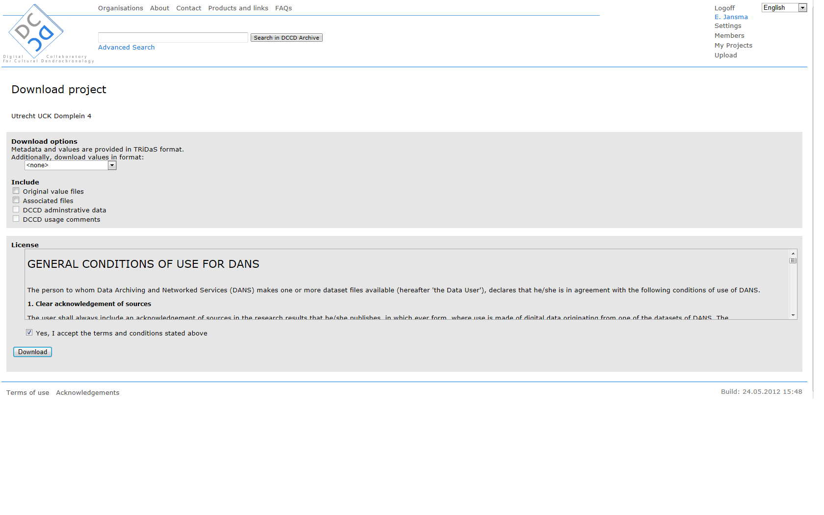

*Download command*

The download command is given by pressing the “Download” button directly underneath the “conditions of use” section.

Downloaded file

A download from the DCCD is a compressed file which always contains a single TRiDaS-XML file in which metadata and data are integrated. Depending on the specified options the compressed file may also contain original value files, different-format value files, and associated files. Members should extract the compressed folder to a location on their PC or network.

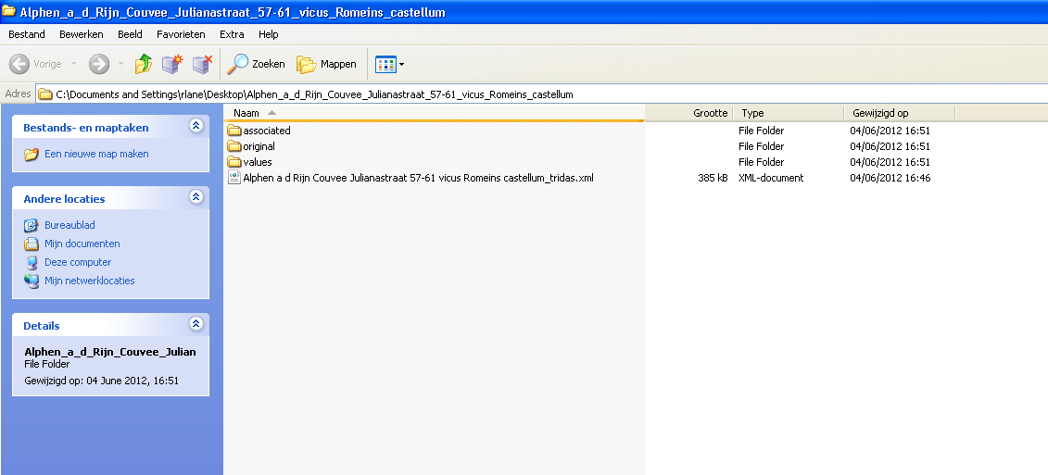

After decompression the data becomes available. The “**associated**” folder contains all associated files. The “**Original**” folder contains the TRiDaS-XML metadata and tree-ring series that were uploaded originally. The “**Values**” folder contains tree-ring series in the format specified by the user before downloading. The XML-file not in a folder contains the single TRiDaS-XML file in which metadata and data are integrated.

**Acknowledgements**

Project team of the DCCD infrastructure

The DCCD infrastructure consists of (a) tree-ring data standard TRiDaS; (b) software for interaction with the DCCD repository; (c) the DCCD repository itself (the topic of this manual); and (d) digital forums for communication, research, education and outreach.

*DCCD infrastructure*

Esther Jansma (Cultural Heritage Agency of the Netherlands (RCE); Utrecht University Faculty of Geosciences) developed the concept of the DCCD infrastructure, initiated its development and supervised its realization (Jansma 2010; Jansma et al. 2012a; Jansma & Van Lanen 2012). Rowin van Lanen (the Netherlands Centre for Dendrochronology/RING Foundation) acted as project assistant and was involved in many aspects of the work.

*TRiDaS*

Together with Peter Brewer (Cornell University) and Ivo Zandhuis (Onderzoek & Advies voor digitale ontsluiting van culturele informatie), Jansma developed the international data-exchange standard TRiDaS (Jansma et al. 2010).

*Software*

Peter Brewer developed the code for the conversion of >20 dendrochronological data formats with help from Daniel Murphy, Esther Jansma and many others (Brewer et al. 2011). In addition he has set up and maintains the TRiDaS website (technical documentation, links to available software) at <http://www.tridas.org>. Kit Sturgeon and Steve Mohlke (The Epison Group, New York) together with Esther Jansma, Rowin van Lanen and Peter Brewer developed TRiDaBASE, a stand-alone MS Access database for interacting with the DCCD web application (Jansma et al. 2012b).

*DCCD repository*

At Digital Archiving and Networked Services (DANS) Paul Boon did the invaluable programming work, Rob Maijers created the usability design of the web application, and Lodewijk Bogaards and Rutger Kramer guarded the development process. At RCE Frans van der Zande guarded the integrity of the DCCD architecture as the work progressed, and Ronald Wiemer and Benjamin Dekker oversaw parts of the work.

*Forums for communication*

Dafne Jansen (Utrecht University) set up the Virtual Knowledge Centre (VKC) for Dendrochronology, an important tool for DCCD-related communication, research, education and outreach managed by Esther Jansma. Peter Brewer set up and maintains the TRiDaS website (technical documentation, links to available software) at <http://www.tridas.org>, and a second more general forum for TRiDaS-based products at <http://tridas.org/forum/>.

*Content of the DCCD*

Many specialists have contributed to the development of TRiDaS (see <http://www.tridas.org/contributors.php> for an overview). The content of the DCD was provided by dendrochronologists in many counties, see the VKC for Dendrochronology at <http://www.uu.nl/vkc/dendrochronology>, website “DCCD user information”, under “Members”.

Funding

The development of the DCCD was funded by the Netherlands Organization for Scientific Research (NWO, section Humanities), through a start-up subsidy (2006-2007), a medium-investment subsidy (2008-2012) and an Internationalization Humanities subsidy (2010-2013). The Cultural Heritage Agency (Rijksdienst voor het Cultureel Erfgoed (RCE), of the Dutch Ministry of Education, Culture and Sciences) and Data Archiving and Networked Services (DANS) provided additional funding. Work on the data in the repository was funded in part by the participating laboratories.

**References**

Brewer, P.W., D. Murhpy & E. Jansma, 2011: [TRiCYCLE: a universal conversion tool for digital tree-ring data](http://vkc.library.uu.nl/vkc/dendrochronology/SiteCollectionDocuments/Brewer%20et%20al%202011.pdf). Tree-Ring Research 67(2), 135-144.

Jansma, E., 2010: Preserving tree-ring data: a repository for the Low Countries. In: M. de Groot & M. Wittenberg (eds.): [Driven by data: exploring the research horizon](http://vkc.library.uu.nl/vkc/dendrochronology/SiteCollectionDocuments/jubileumbundel_DANS_nov.pdf), Amsterdam University Press/Pallas Publications, 29-33.

Jansma, E., P.W. Brewer & I. Zandhuis 2010: [TRiDaS 1.1: the tree-ring data standard](http://www.sciencedirect.com/science?_ob=ArticleURL&_udi=B7GJ1-4XSV0RH-1&_user=10&_coverDate=12/31/2010&_rdoc=1&_fmt=high&_orig=search&_origin=search&_sort=d&_docanchor=&view=c&_acct=C000050221&_version=1&_urlVersion=0&_userid=10&md5=71e40c4bb749b46fc5749d145dfebf1d&searchtype=a). Dendrochronologia 28, 99-130.

Jansma, E. & R.J. van Lanen, 2012 (in druk): Een digitale bibliotheek van dateringen: de internationale doorwerking van een Nederlands initiatief. Vitruvius, 36-41.

Jansma, E., R.J. van Lanen, P.W. Brewer & R. Kramer (2012a): The DCCD: a digital data infrastructure for tree-ring research. Dendrochronologia (in press), <http://dx.doi.org/10.1016/j.dendro.2011.12.002>.

Jansma, E., R.J. van Lanen, K. Sturgeon, S. Mohlke & P.W. Brewer, 2012b: TRiDaBASE, a stand-alone database for storage, analysis and exchange of dendrochronological metadata. Dendrochronologia 30(3), 209-211. [doi:10.1016/j.dendro.2011.09.002](http://www.sciencedirect.com/science/article/pii/S1125786511000828).

**Websites**

<http://dendro.dans.knaw.nl> DCCD repository for tree-ring data

<http://www.uu.nl/vkc/dendrochronology> DCCD user information, DCCD project website

<http://www.tridas.org> TRiDaS: technical descriptions, software

<http://tridas.org/forum/> Discussion forum (TRiDaS, TRiDaS-based software)